

**DEPARTMENT OF INFORMATION TECHNOLOGY**

## LAB MANUAL

**CLASS: TE-IT SEMESTER:VI**

## SUBJECT: SOFTWARE LABORATORY – VI

**PREPARED BY: MRS. ANUJA PHAPALE**

AISSMS IOIT, Department of Information Technology Page 1

|  |  |  |  |  |  |  |  |
| --- | --- | --- | --- | --- | --- | --- | --- |
| **DEPARTMENT OF INFORMATION TECHNOLOGY**  **TEACHING SCHEME** | | | | | | | |
|  | **In-charge** | **:** | **Mr. Anuja Phapale** | **Teaching Scheme** | **:** | **04Hr/Week** |  |
| **Practical** | **:** | **25 Marks** | **Term Work** | **:** | **25 Marks** |
| **Oral** | **:** | **-** | **Course Code** | **:** | **314457** |
|  |  | | | | | | |
| AISSMS IOIT, Department of Information Technology Page 2 | | | | | | | |

|  |  |  |  |  |
| --- | --- | --- | --- | --- |
| **DEPARTMENT OF INFORMATION TECHNOLOGY**  **INDEX** | | | | |
|  | **Sr.**  **No.** | **Content** | **Page no.** |  |
| 1 | Department vision ,Mission, Program Educational Objectives ,  Program Specific Out comes and Program Outcomes | 4 |
| 2 | SPPU course objective and outcome | 6 |
| 3 | Department course objective and outcome | 7 |
| 4 | SPPU suggested List of Laboratory Assignments | 9 |
| 5 | Department conducted List of Laboratory Assignments | 10 |
| 6 | Assignment No: 1 | 13 |
| 7 | Assignment No: 2 | 34 |
| 8 | Assignment No: 3 | 39 |
| 9 | Assignment No: 4 | 41 |
| 10 | Assignment No: 5 | 46 |
| 11 | Assignment No: 6 | 54 |
| 12 | Assignment No: 7 | 55 |
| 13 | Assignment No: 8 | 57 |
| 14 | Assignment No: 9 | 64 |
| 15 | References | 74 |
|  |  | | | |
| AISSMS IOIT, Department of Information Technology Page 3 | | | | |



**Vision**

To equip students with core and state of the art Information Technologies.

**Mission**

Imparting knowledge of Information Technology and teaching its application through innovative practices and to instil high morale, ethics, lifelong learning skills, concern for the society and environment.

**Program Educational Objectives**

1. To prepare graduates to solve multifaceted and complex problems in IT industries.
2. To inculcate core professional skills with latest information technology to prepare graduates for employment and higher studies.
3. To develop cross domain competences that prepares graduates for lifelong learning in diverse career paths.
4. To make graduates aware of their social responsibilities toward environment and society.

**Program Specific Outcomes**

1. Graduates will be able to demonstrate database, networking and programming technologies.
2. Graduates will be able to apply core professional state of the art Information Technology

**Program Outcomes**

### Graduates will be able to

* 1. Apply the knowledge of mathematics, science, engineering fundamentals, and an engineering specialization to the solution of complex engineering problems.**[Engineering knowledge]**
  2. Identify, formulate, research literature, and analyse complex engineering problems reaching substantiated conclusions using first principles of mathematics, natural sciences, and engineering sciences.**[Problem analysis]**
  3. Design solutions for complex engineering problems and design system components or processes that meet the specified needs with appropriate consideration for the public health and safety, and the cultural, societal, and environmental considerations.**[Design/development of solutions]**
  4. Use research-based knowledge and research methods including design of experiments, analysis and interpretation of data, and synthesis of the information to provide valid conclusions.**[Conduct investigations of complex problems]**
  5. Create, select, and apply appropriate techniques, resources, and modern engineering and IT tools including prediction and modelling to complex engineering activities with an understanding of the limitations. **[Modern tool usage]**
  6. Apply reasoning informed by the contextual knowledge to assess societal, health, safety, legal and cultural issues and the consequent responsibilities relevant to the professional engineering practice.**[The engineer and society]**
  7. Understand the impact of the professional engineering solutions in societal and environmental contexts, and demonstrate the knowledge of, and need for sustainable development.**[Environment and sustainability]**
  8. Apply ethical principles and commit to professional ethics and responsibilities and norms of the engineering practice.**[Ethics]**
  9. Function effectively as an individual, and as a member or leader in diverse teams, and in multidisciplinary settings.**[Individual and team work]**
  10. Communicate effectively on complex engineering activities with the engineering community and with society at large, such as, being able to comprehend and write effective reports and design documentation, make effective presentations, and give and receive clear instructions.**[Communication]**
  11. Demonstrate knowledge and understanding of the engineering and management principles and apply these to one’s own work, as a member and leader in a team, to manage projects and in multidisciplinary environments**.[Project management and finance]**
  12. Recognize the need for, and have the preparation and ability to engage in independent and life- long learning in the broadest context of technological change**.[Life-long learning]**



## SPPU COURSE OBJECTIVE AND OUTCOME

**Prerequisites:**

1. Engineering and discrete mathematics.
2. Database Management Systems, Data warehousing, Data mining.
3. Programming skill.

## Course Objectives:

1. To understand Big data primitives and fundamentals.
2. To understand the different Big data processing techniques.
3. To understand and apply the Analytical concept of Big data using R/Python.
4. To understand different data visualization techniques for Big Data
5. To understand the application and impact of Big Data
6. To understand emerging trends in Big data analytics

## Course Outcomes :

After successful completion of this course, student will be able to

1. To apply Big data primitives and fundamentals for application development.
2. To explore different Big data processing techniques with use cases.
3. To apply the Analytical concept of Big data using R/Python.
4. To visualize the Big Data using Tableau.
5. To design algorithms and techniques for Big data analytics.
6. To design Big data analytic application for emerging trends.



## DEPARTMENT COURSE OBJECTIVE AND OUTCOME

|  |  |
| --- | --- |
| *Course Objectives* | |
| 1 | To introduce the basic need of Big Data and Data science to handle huge amounts of data. |
| 2 | To understand the basic mathematics behind the Big data. |
| 3 | To understand the different Big data processing technologies. |
| 4 | To understand and apply the Analytical concept of Big data using R and Python. |
| 5 | To visualize the Big Data using different tools. |
| 6 | To understand the application and impact of Big Data. |

|  |  |
| --- | --- |
| *Course Outcomes :* Students will be able to | |
| C310.1 | Describe Big Data primitives. |
| C310.2 | Apply different mathematical models for Big Data. |
| C310.3 | Demonstrate Big Data learning skills by developing industry or research applications. |
| C310.4 | Analyze learning models of different algorithmic approaches using datasets. |
| C310.5 | Apply big data visualization techniques. |
| C310.6 | Use different programming platforms for big data analytics. |

|  |  |  |  |  |  |  |  |  |  |  |  |  |  |  |  |  |  |  |  |  |  |  |  |  |  |  |  |  |  |  |  |  |  |  |  |  |  |  |  |  |  |  |  |  |  |  |  |  |  |  |  |  |  |  |  |  |  |  |  |  |  |  |  |  |  |  |  |  |  |  |  |  |  |  |  |  |  |  |  |  |  |  |  |  |  |  |  |  |  |  |  |  |  |  |  |  |  |  |  |  |  |  |  |  |  |  |  |  |  |  |  |  |  |  |  |  |  |  |  |  |  |  |
| --- | --- | --- | --- | --- | --- | --- | --- | --- | --- | --- | --- | --- | --- | --- | --- | --- | --- | --- | --- | --- | --- | --- | --- | --- | --- | --- | --- | --- | --- | --- | --- | --- | --- | --- | --- | --- | --- | --- | --- | --- | --- | --- | --- | --- | --- | --- | --- | --- | --- | --- | --- | --- | --- | --- | --- | --- | --- | --- | --- | --- | --- | --- | --- | --- | --- | --- | --- | --- | --- | --- | --- | --- | --- | --- | --- | --- | --- | --- | --- | --- | --- | --- | --- | --- | --- | --- | --- | --- | --- | --- | --- | --- | --- | --- | --- | --- | --- | --- | --- | --- | --- | --- | --- | --- | --- | --- | --- | --- | --- | --- | --- | --- | --- | --- | --- | --- | --- | --- | --- | --- | --- | --- |
| **DEPARTMENT OF INFORMATION TECHNOLOGY**  **CO-PO-PSO Mapping:**   |  |  |  |  |  |  |  |  |  |  |  |  |  |  |  | | --- | --- | --- | --- | --- | --- | --- | --- | --- | --- | --- | --- | --- | --- | --- | | PO  CO | PO  1 | PO  2 | PO  3 | PO  4 | PO  5 | PO  6 | PO  7 | PO  8 | PO  9 | PO  10 | PO  11 | PO  12 | PSO  1 | PSO  2 | | **C310.1** | 3 | 2 | 1 | - | 1 | - | - | 2 | 2 | 2 | - | 2 | - | 3 | | **C310.2** | 2 | 2 | 1 | - | - | - | - | 2 | 2 | 2 | - | 2 | - | 3 | | **C310.3** | 3 | 2 | 2 | 1 | 2 | - | - | 2 | 2 | 2 | - | 2 | 3 | 3 | | **C310.4** | 3 | 2 | 2 | 2 | 2 | - | - | 2 | 2 | 2 | - | 2 | 3 | 3 | | **C310.5** | 3 | 2 | 2 | 2 | 2 | - | - | 2 | 2 | 2 | - | 2 | 3 | 3 | | **C310.6** | 2 | 2 | 1 | - | 1 | - | - | 2 | 2 | 2 | - | 2 | - | 3 | | **C310** | **3** | **2** | **2** | **2** | **2** | **-** | **-** | **2** | **2** | **2** | **-** | **2** | **3** | **3** | | |  |
|  | AISSMS IOIT, Department of Information Technology Page 8 |  |

|  |  |  |  |
| --- | --- | --- | --- |
| **DEPARTMENT OF INFORMATION TECHNOLOGY**  **SPPU Suggested List of Laboratory Assignments Software Laboratory- VI** | | | |
|  | **Sr.No.** | **Practical List** |  |
| **Part A : Assignments based on the Hadoop** | |
| 1 | Hadoop Installation on a)Single Node b)Multiple Node |
| 2 | Design a distributed application using MapReduce which processes a log file of a system. List out the users who have logged for maximum period on the system. Use simple log file from the Internet and process it using a pseudo distribution mode on  Hadoop platform. |
| 3 | Design and develop a distributed application to find the coolest/hottest year from the  available weather data. Use weather data from the Internet and process it using MapReduce. |
| 4 | Write an application using HBase and HiveQL for flight information system which will include   1. Creating, Dropping, and altering Database tables 2. Creating an external Hive table to connect to the HBase for Customer Information Table 3. Load table with data, insert new values and field in the table, Join tables with Hive 4. Create index on Flight information Table 5. Find the average departure delay per day in 2008. |
| **Part B : Assignments based on R and Python** | |
| 5 | Perform the following operations using R/Python on the Amazon book review and facebook metrics data sets   1. Create data subsets 2. Merge Data 3. Sort Data 4. Transposing Data 5. Melting Data to long format 6. Casting data to wide format |
| 6 | Perform the following operations using R/Python on the Air quality and Heart Diseases data sets   1. Data cleaning 2. Data integration 3. Data transformation 4. Error correcting 5. Data model building |
| 7 | Integrate R/Python and Hadoop and perform the following operations on forest fire dataset   1. Text mining in RHadoop 2. Data analysis using the Map Reduce in Rhadoop |
|  |  | | |
| AISSMS IOIT, Department of Information Technology Page 9 | | | |

|  |  |  |  |
| --- | --- | --- | --- |
| **DEPARTMENT OF INFORMATION TECHNOLOGY** | | | |
|  |  | 3) Data mining in Hive |  |
| 8 | Visualize the data using R/Python by plotting the graphs for assignment no. 2 and 3 |
| 9 | Perform the following data visualization operations using Tableau on Adult and Iris datasets   1. 1D (Linear) Data visualization 2. 2D (Planar) Data Visualization 3. 3D (Volumetric) Data Visualization 4. Temporal Data Visualization 5. Multidimensional Data Visualization 6. Tree/ Hierarchical Data visualization 7. Network Data visualization |
| **Part C : Case Study Assignment** | |
| 10 | Social Media Analytics |
| 11 | Text Mining/ Text Analytics |
| 12 | Mobile Analytics |
|  |  | | |
| AISSMS IOIT, Department of Information Technology Page 10 | | | |

|  |  |  |  |  |  |  |  |  |  |  |  |  |  |  |  |  |  |  |  |  |  |  |  |  |  |  |  |  |  |  |  |  |  |  |  |  |  |  |  |  |  |  |  |  |  |  |  |  |  |  |  |  |  |  |  |  |  |  |  |  |  |  |  |  |  |  |  |  |  |  |  |  |  |  |  |  |  |  |  |  |  |
| --- | --- | --- | --- | --- | --- | --- | --- | --- | --- | --- | --- | --- | --- | --- | --- | --- | --- | --- | --- | --- | --- | --- | --- | --- | --- | --- | --- | --- | --- | --- | --- | --- | --- | --- | --- | --- | --- | --- | --- | --- | --- | --- | --- | --- | --- | --- | --- | --- | --- | --- | --- | --- | --- | --- | --- | --- | --- | --- | --- | --- | --- | --- | --- | --- | --- | --- | --- | --- | --- | --- | --- | --- | --- | --- | --- | --- | --- | --- | --- | --- | --- |
| **DEPARTMENT OF INFORMATION TECHNOLOGY**  **Department conducted List of Laboratory Assignments Software Laboratory- VI**   |  |  |  |  |  | | --- | --- | --- | --- | --- | | **Sr. No.** | **Practical List** | **CO** | **PO** | **PSO** | | **Part A : Assignments based on the Hadoop** | | | | | | 1. | Hadoop Installation on a)Single Node b)Multiple Node | C310.3 | 1,2,3,4,5,8,9,10,12 | 1,2 | | 2. | Design a distributed application using MapReduce which processes a log file of a system. List out the users who have logged for maximum period on the system. Use simple log file from the Internet and process it using a pseudo distribution mode on Hadoop platform. | C310.3 | 1,2,3,4,5,8,9,10,12 | 1,2 | | 3. | Design and develop a distributed application to find the coolest/hottest year from the available weather data. Use weather data from the Internet and process it using MapReduce. | C310.3 | 1,2,3,4,5,8,9,10,12 | 1,2 | | 4. | Write an application using HBase and HiveQL for flight information system which will include  1) Creating, Dropping, and altering Database tables  2) Creating an external Hive table to connect to the HBase for Customer Information Table  3) Load table with data, insert new values and field in the table, Join tables with Hive  4) Create index on Flight information Table 5) Find the average departure delay per day in 2008. | C310.3 | 1,2,3,4,5,8,9,10,12 | 1,2 | | 5. | Perform the following operations using R/Python on the Amazon book review and facebook metrics data sets  5) Create data subsets  6) Merge Data  7) Sort Data  8) Transposing Data  9) Melting Data to long format  10) Casting data to wide format | C310.4 | 1,2,3,4,5,8,9,10,12 | 1,2 | | **Part B : Assignments based on R and Python** | | | | | | 6. | Perform the following operations using R/Python on the Air quality and Heart Diseases data sets  1) Data cleaning  2) Data integration  3) Data transformation  4) Error correcting  5) Data model building | C310.4 | 1,2,3,4,5,8,9,10,12 | 1,2 | | 7. | Integrate R/Python and Hadoop and perform the following operations on forest fire dataset  1) Text mining in RHadoop  2) Data analysis using the Map Reduce in Rhadoop  3) Data mining in Hive | C310.4 | 1,2,3,4,5,8,9,10,12 | 1,2 | | 8. | Visualize the data using R/Python by plotting the graphs for assignment no. 2 and 3 | C310.4 | 1,2,3,4,5,8,9,10,12 | 1,2 | | 9. | Perform the following data visualization operations using Tableau on Adult and Iris datasets  1) 1D (Linear) Data visualization  2) 2D (Planar) Data Visualization  3) 3D (Volumetric) Data Visualization  4) Temporal Data Visualization  5) Multidimensional Data Visualization  6) Tree/ Hierarchical Data visualization  7) Network Data visualization | C310.5 | 1,2,3,4,5,8,9,10,12 | 1,2 | | **Part C : Case Study Assignment** | | | | | | 10. | Social Media Analytics | C310.5 | 1,2,3,4,5,8,9,10,12 | 1,2 | | 11. | Text Mining/ Text Analytics | C310.5 | 1,2,3,4,5,8,9,10,12 | 1,2 | | 12. | Mobile Analytics | C310.5 | 1,2,3,4,5,8,9,10,12 | 1,2 | | |
|  |  |
| AISSMS IOIT, Department of Information Technology Page 11 | |



**Assignment No: 1 Title:** Hadoop Installation on a)Single Node b)Multiple Node **Learning Objectives:**

### Problem Statement:

Study and perform Hadoop Installation on a)Single Node b)Multiple Node

**Learning Outcome**: Students will able to

* Install hadoop.

### Software and Hardware Requirement:

* PC with Ubuntu

### Theory:

**What is Hadoop?**

Hadoop is an open source framework from Apache and is used to store process and analyze data which are very huge in volume. Hadoop is written in Java and is not OLAP (online analytical processing). It is used for batch/offline processing.It is being used by Facebook, Yahoo, Google, Twitter, LinkedIn and many more. Moreover it can be scaled up just by adding nodes in the cluster.

### Modules of Hadoop:

* 1. HDFS: Hadoop Distributed File System. Google published its paper GFS and on the basis of that HDFS was developed. It states that the files will be broken into blocks and stored in nodes over the distributed architecture.
  2. Yarn: Yet another Resource Negotiator is used for job scheduling and manage the cluster.
  3. Map Reduce: This is a framework which helps Java programs to do the parallel computation on data using key value pair. The Map task takes input data and converts it into a data set which can be computed in Key value pair. The output of Map task is consumed by reduce task and then the out of reducer gives the desired result.
  4. Hadoop Common: These Java libraries are used to start Hadoop and are used by other

Hadoop modules.

Advantages of Hadoop:

* + Fast: In HDFS the data distributed over the cluster and are mapped which helps in faster retrieval. Even the tools to process the data are often on the same servers, thus reducing the processing time. It is able to process terabytes of data in minutes and Peta bytes in hours.
  + Scalable: Hadoop cluster can be extended by just adding nodes in the cluster.
  + Cost Effective: Hadoop is open source and uses commodity hardware to store data so it really cost effective as compared to traditional relational database management system.
  + Resilient to failure: HDFS has the property with which it can replicate data over the network, so if one node is down or some other network failure happens, then takes the other copy of data and use it. Normally, data are replicated thrice but the replication factor is configurable.1

Steps to install single node Hadoop:

1. You must have JDK 1.7 or more installed on UBUNTU 14.04, To check just issue a command: ~$ java -version

To install jdk just type command: sudo apt-get install default-jdk

1. Add a dedicated Hadoop user: 2.1: sudo addgroup hadoop

2.2: sudo adduser --ingroup hadoop hduser 2.3: sudo adduser hduser sudo

1. Install SSH:

ssh has two main components:

ssh : The command we use to connect to remote machines - the client.

sshd : The daemon that is running on the server and allows clients to connect to the server.

The ssh is pre-enabled on Linux, but in order to start sshd daemon, we need to install ssh first. Use this command to do that : sudo apt-get install openssh-server

To check if ssh is installed properly, issue following commands:

* 1. which ssh
  2. which sshd Create and Setup SSH Certificates

1. su hduser
2. cd
3. ssh-keygen -t rsa -P ""

- If asked for a filename just leave it blank and press the enter key to continue

1. cat $HOME/.ssh/id\_rsa.pub >> $HOME/.ssh/authorized\_keys
2. To check if ssh works, type: ssh localhost

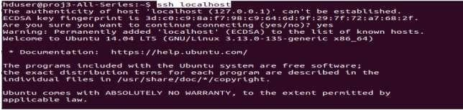

1. exit

### Install Hadoop:

Download & extract:

* Go to Link: <http://www-eu.apache.org/dist/hadoop/common/> and download Hadoop 2.9 version hadoop-2.9.0.tar.gz
* go the location where the downloaded file is present and extract using below command
* tar -xvf hadoop-2.9.0.tar.gz

move the Hadoop installation to the /usr/local/hadoop directory using the following command: sudo mv hadoop-2.9.0 /usr/local/hadoop

Now, change the owner of hadoop folder using command:

* sudo chown -R hduser /usr/local/

### Setup Configuration Files

The following files will have to be modified to complete the Hadoop setup:

### ~/.bashrc:

Before editing the .bashrc file in our home directory, we need to find the path where Java has been installed to set the JAVA\_HOME environment variable using the following command: update-alternatives --config java

Now we can append the following to the end of ~/.bashrc: vi ~/.bashrc

#HADOOP VARIABLES START

export JAVA\_HOME=/usr/lib/jvm/java-7-openjdk-amd64 export HADOOP\_HOME=/usr/local/hadoop

export PATH=$PATH:$HADOOP\_HOME/bin export PATH=$PATH:$HADOOP\_HOME/sbin export HADOOP\_MAPRED\_HOME=$HADOOP\_HOME export HADOOP\_COMMON\_HOME=$HADOOP\_HOME export HADOOP\_HDFS\_HOME=$HADOOP\_HOME

export YARN\_HOME=$HADOOP\_HOME

export HADOOP\_COMMON\_LIB\_NATIVE\_DIR=$HADOOP\_HOME/lib/native

Next issue the following command: source ~/.bashrc

note that the JAVA\_HOME should be set as the path just before the '.../bin/':

### /usr/local/hadoop/etc/hadoop/hadoop-env.sh

We need to set JAVA\_HOME by modifying hadoop-env.sh file. vi /usr/local/hadoop/etc/hadoop/hadoop-env.sh

export JAVA\_HOME=/usr/lib/jvm/java-7-openjdk-amd64

Adding the above statement in the hadoop-env.sh file ensures that the value of JAVA\_HOME variable will be available to Hadoop whenever it is started up.

### /usr/local/hadoop/etc/hadoop/core-site.xml:

The /usr/local/hadoop/etc/hadoop/core-site.xml file contains configuration properties that Hadoop uses when starting up.

Open the file and enter the following in between the <configuration></configuration> tag:



~$ sudo gedit /usr/local/hadoop/etc/hadoop/core-site.xml

<property>

<name>fs.default.name</name>

<value>hdfs://localhost:9000</value>

### /usr/local/hadoop/etc/hadoop/mapred-site.xml

By default, the /usr/local/hadoop/etc/hadoop/ folder contains

/usr/local/hadoop/etc/hadoop/mapred-site.xml.template file which has to be renamed/copied with the name mapred-site.xml using command:

cp /usr/local/hadoop/etc/hadoop/mapred-site.xml.template

The mapred-site.xml file is used to specify which framework is being used for MapReduce. We need to enter the following content in between the <configuration></configuration> tag:

<property>

<name>mapreduce.framework.name</name>

<value>yarn</value>

### /usr/local/hadoop/etc/hadoop/hdfs-site.xml

The /usr/local/hadoop/etc/hadoop/hdfs-site.xml file needs to be configured for each host in the cluster that is being used. It is used to specify the directories which will be used as the namenode and the datanode on that host.

Before editing this file, we need to create two directories which will contain the namenode and the datanode for this Hadoop installation. This can be done using the following commands:

~$ sudo mkdir -p /usr/local/hadoop\_tmp/hdfs/namenode

~$ sudo mkdir -p /usr/local/hadoop\_tmp/hdfs/datanode

~$ sudo chown -R hduser:hadoop /usr/local/hadoop\_tmp

Open the file and enter the following content in between the <configuration></configuration> tag:

~$ sudo gedit /usr/local/hadoop/etc/hadoop/hdfs-site.xml

<property>

<name>dfs.replication</name>

<value>1</value>

</property>

<property>

<name>dfs.namenode.name.dir</name>

<value>file:/usr/local/hadoop\_tmp/hdfs/namenode</value>

</property>

<property>

<name>dfs.datanode.data.dir</name>

1. Edit the yarn-site.xml file and paste the code given below in <configuration> tags.



sudo gedit /usr/local/hadoop/etc/hadoop/yarn-site.xml

<property>

<name>yarn.nodemanager.aux-services</name>

<value>mapreduce\_shuffle</value>

</property>



### Format the New Hadoop Filesystem

<name>yarn.nodemanager.aux- services.mapreduce.shuffle.class</name>

<value>org.apache.hadoop.mapred.ShuffleHandler</value>

</property>

Now, the Hadoop file system needs to be formatted so that we can start to use it. The format command should be issued with write permission since it creates current directory

under /usr/local/hadoop\_store/hdfs/namenode folder:

hduser@laptop:~$ hadoop namenode -format

.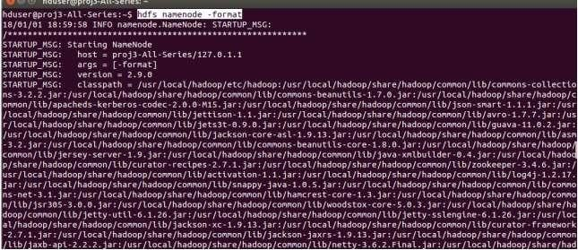

.

.



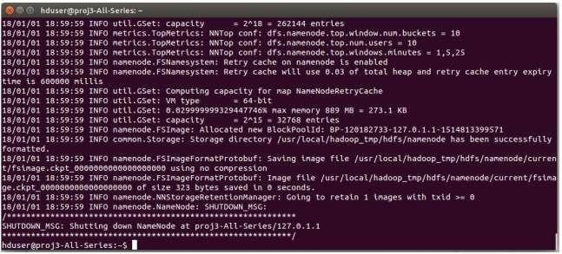



### Note that hadoop namenode -format command should be executed once before we start using Hadoop. If this command is executed again after Hadoop has been used, it'll destroy all the data on the Hadoop file system.

1. **Starting Hadoop**

Now it's time to start the newly installed single node cluster. We can use start-all.sh or (start-dfs.sh and start-yarn.sh)

k@laptop:~$ cd /usr/local/hadoop/sbin

k@laptop:/usr/local/hadoop/sbin$ ls

distribute-exclude.sh hadoop-daemon.sh hadoop-daemons.sh

hdfs-config.cmd

start-all.cmd start-all.sh start-balancer.sh start-dfs.cmd

start-dfs.sh

stop-balancer.sh

stop-dfs.cmd stop-dfs.sh

hdfs-config.sh

httpfs.sh kms.sh

start-secure-dns.sh start-yarn.cmd

start-yarn.sh

stop-secure-dns.sh stop-yarn.cmd

stop-yarn.sh

yarn-daemon.sh

mr-jobhistory-daemon.sh

stop-all.cmd

k@laptop:/usr/local/hadoop/sbin$ sudo su hduser

hduser@laptop:/usr/local/hadoop/sbin$ start-all.sh

hduser@laptop:~$ start-all.sh

We can check if it's really up and running:



hduser@laptop:/usr/local/hadoop/sbin$ jps 9026 NodeManager



9766 Jps

8887 ResourceManager

The output means that we now have a functional instance of Hadoop running on our VPS (Virtual private server).

### Stopping Hadoop

$ pwd

/usr/local/hadoop/sbin

$ ls

distribute-exclude.sh httpfs.sh

start-yarn.cmd

stop-dfs.cmd

start-all.sh

yarn-daemon.sh

hadoop-daemon.sh start-yarn.sh

hadoop-daemons.sh stop-all.cmd

mr-jobhistory-daemon.sh

start-balancer.sh

stop-dfs.sh

yarn-daemons.sh

refresh-namenodes.sh

stop-secure-dns.sh

start-dfs.cmd

hdfs-config.cmd

stop-all.sh

slaves.sh

stop-yarn.cmd

start-dfs.sh

stop-balancer.sh stop-yarn.sh

We run stop-all.sh or (stop-dfs.sh and stop-yarn.sh) to stop all the daemons running on our machine:



hduser@laptop:/usr/local/hadoop/sbin$ pwd

/usr/local/hadoop/sbin hduser@laptop:/usr/local/hadoop/sbin$ ls

distribute-exclude.sh

hadoop-daemon.sh start-yarn.cmd

httpfs.sh

kms.sh stop-dfs.cmd

start-all.cmd stop-yarn.sh

start-all.sh

hadoop-daemons.sh

mr-jobhistory-daemon.sh

start-balancer.sh

stop-dfs.sh

yarn-daemons.sh

hdfs-config.cmd stop-all.cmd

hdfs-config.sh stop-all.sh

refresh-namenodes.sh stop-secure-dns.sh

slaves.sh stop-yarn.cmd

start-dfs.cmd

start-dfs.sh

hduser@laptop:/usr/local/hadoop/sbin$

hduser@laptop:/usr/local/hadoop/sbin$ stop-all.sh

### Hadoop Web Interfaces

Let's start the Hadoop again and see its Web UI: hduser@laptop:/usr/local/hadoop/sbin$ start-all.sh

### http://localhost:50070/ - web UI of the NameNode daemon



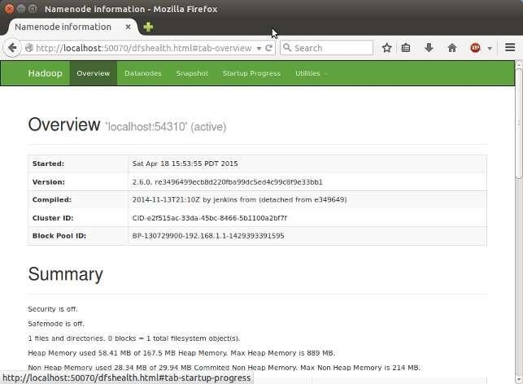

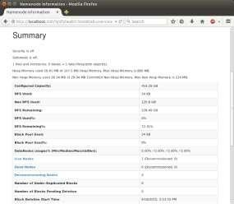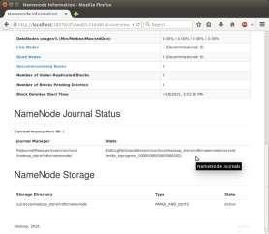

**SecondaryNameNode**

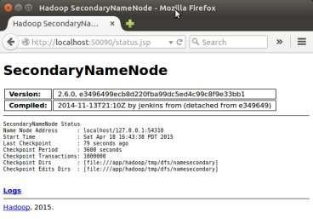

(Note) U have to restart Hadoop to get this Secondary Namenode.

### DataNode

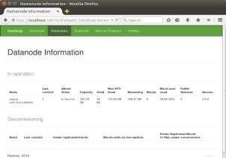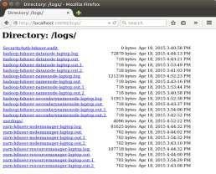

**Steps to install Multi Node Hadoop Cluster:**

For simplicity, we use 1 node as master and 1 as slave.

Make sure all slave nodes are reachable from master node. To avoid any unreachable hosts error, make sure you add the slave hostnames and ip addresses in /etc/hosts file. Similarly, slave nodes should be able to resolve master hostname.

1. Install Java (as done previously) on all the slaves and master.
2. Disable IPv6 (if applicable) using command below:

sudo **sed** -i '**s**/net.ipv6.bindv6only\ =\ 1/net.ipv6.bindv6only\ =\ 0/' \

1. Setting up Hadoop User:

Hadoop talks to other nodes in the cluster using no-password ssh. Lets’s create a user hadoopuser on master as well as slave nodes.

# Create hadoopgroup

$ sudo addgroup hadoopgroup

Our next step will be to generate a ssh key for password-less login between master and slave nodes. Run the following commands only on master node.

# Login as hadoopuser

$ su - hadoopuser

#Generate a ssh key for the user

$ ssh-keygen -t rsa -P ""

Run the below two commands on each slave node:

#Copy this key to slave-1 to enable password less ssh

$ ssh-copy-id -i ~/**.**ssh/id\_rsa.pub slave-1

1. Download and Install Hadoop binaries on Master and Slave nodes

Do this step on master and every slave node. Extract and copy the hadoop folder to path

/usr/local/hadoop

1. Setup Hadoop Environment on Master and Slave Nodes

Copy and paste following lines into your .bashrc file under /home/hadoopuser/. Do

this step on master and every slave node.

# Set HADOOP\_HOME

**export** HADOOP\_HOME=/usr/local/hadoop #

Set JAVA\_HOME

**export** JAVA\_HOME=/usr/lib/jvm/java-7-openjdk-amd64 #

Update JAVA\_HOME in /usr/local/hadoop/etc/hadoop/hadoop\_env.sh to following. Do this step on master and every slave node.

**export** JAVA\_HOME=/usr/lib/jvm/java-7-openjdk-amd64

1. Update Configuration Files

Add/update core-site.xml on Master and Slave nodes with following options. Master and slave nodes should all be using the same value for this property fs.defaultFS, and should be pointing to master node only.

<value>/usr/local/tmp</value>

|  |
| --- |
| **/home/hadoopuser/hadoop/etc/hadoop/core-site.xml** |
| <property>  <name>hadoop.tmp.dir</name> |
| **/home/hadoopuser/hadoop/etc/hadoop/mapred-site.xml** |
| <description>Temporary Directory.</description>  </property>  <property> |

Add/update mapred-site.xml on Master node only with following options.

<property>

<name>mapreduce.jobtracker.address</name>

<value>master:54311</value>

<description>The host and port that the MapReduce job tracker runs at. If “local”, then jobs are run in-process as a single map and reduce task.

</description>

</property>

Add/update hdfs-site.xml on Master and Slave Nodes. We will be adding following three entries to the file.

* + **dfs.replication**– Here we will be using a replication factor of 2. That means for every file stored in HDFS, there will be one redundant replication of that file on some other node in the cluster.
  + **dfs.namenode.name.dir** – This directory is used by Namenode to store its metadata file. Here we manually created this directory on master and slave node, and use the directory location for this configuration.
  + **dfs.datanode.data.dir** – This directory is used by Datanode to store hdfs data blocks. Here we manually created this directory on master and slave node, and use the directory location for this configuration.

**/home/hadoopuser/hadoop/etc/hadoop/hdfs-site.xml [(Other Options)](http://hadoop.apache.org/docs/current/hadoop-project-dist/hadoop-hdfs/hdfs-default.xml)**

<property>

<name>dfs.replication</name>

<value>2</value>

<description>Default block replication.

The actual number of replications can be specified when the file is created.

The default is used if replication is not specified in create time.

</description>

SMS IOIT, Department of Information Technology



AIS

</property>

Page 30



</description>

</property>

<property>

<name>dfs.datanode.data.dir</name>

<value>/usr/local/hadoop\_tmp /hdfs/datanode</value>

<description>Determines where on the local filesystem an DFS data node should

Add yarn-site.xml on Master and Slave Nodes. This file is required for a Node to work as a Yarn Node. Master and slave nodes should all be using the same value for the following properties, and should be pointing to master node only.

<property>

<name>yarn.nodemanager.aux-services</name>

<value>mapreduce\_shuffle</value>

</property>

<property>

<name>yarn.resourcemanager.scheduler.address</name>

<value>IP\_of\_Master:8030</value>

</property>

<property>

<name>yarn.resourcemanager.address</name>

<value> IP\_of\_Master:8032</value>

</property>

<property>

<name>yarn.resourcemanager.webapp.address</name>

**/home/hadoopuser/hadoop/etc/hadoop/yarn-site.xml**

<value> IP\_of\_Master:8088</value>

</property>

<property>

<name>yarn.resourcemanager.resource-tracker.address</name>

<value> IP\_of\_Master:8031</value>

</property>

<property>

<name>yarn.resourcemanager.admin.address</name>

<value> IP\_of\_Master:8033</value>

</property>

Add/update slaves file on Master node only. Add just name, or ip addresses of master and all slave node. If file has an entry for localhost, you can remove that.

slave-1

Master

**/home/hadoopuser/hadoop/etc/hadoop/slave**

1. Format the Namenode

Before starting the cluster, we need to format the Namenode. Use the following command only on master node:

hdfs namenode -format

1. Start the Distributed Format System

Run the following on master node command to start the DFS.

$ sudo /usr/local/hadoop/sbin/start-dfs.sh

To validate the success, run following command on master nodes, and slave node.

$ su - hadoopuser

The output of this command should list **NameNode, SecondaryNameNode, DataNode** on **master node**, and **DataNode** on all **slave nodes**. If you don’t see the expected output, review the log files listed in Troubleshooting section.

1. Start the Yarn MapReduce Job tracker

Run the following command to start the Yarn mapreduce framework.

$ **sudo** /usr/local/hadoop/sbin/start-yarn.sh

To validate the success, run jps command again on master nodes, and slave node. The output of this command should list **NodeManager, ResourceManager** on **master node**, and **NodeManager**, on all **slave nodes**. If you don’t see the expected output, review the log files to troubleshoot

**Conclusion:** Single node and multi-node installation of hadoop is completed successfully. With hadoop version 2.9.0.

## Assignment No: 2

**Title:** Design a distributed application using MapReduce which processes a log file of a system. List out the users who have logged for maximum period on the system. Use simple log file from the Internet and process it using a pseudo distribution mode on Hadoop platform.

### Learning Objectives:

**Problem Statement:**

Study and perform program using map reduce on Hadoop.

**Learning Outcome**: Students will able to

* Implement map reduce program

### Software and Hardware Requirement:

* PC with Ubuntu and Hadoop installed.

### Theory:

**Map-Reduce programming model:**

Mapreduce is a framework for processing big data in two phases Map & Reduce. Both the phases have key-value pairs as input and output. Map phase implements Mapper function, in which user-provided code will be executed on each key-value pair (k1, v1) read from the input files. The output of the mapper function would be zero or more key-value pairs (k2, v2) which are called intermediate pairs. Here the key is what the data will be grouped on and the value is the information related to the analysis in the reducer.

Reduce phase takes mapper output (grouped key-value data) (k2, v2) and runs reduce function on each key-value group. reduce function iterates over the list of values associated with a key and produces outputs like aggregations, statistics etc.. Once the reduce function is done, it sends zero or more key-value pairs (k3, v3) to the final the output file. By default, Mapreduce input and output file formats are text file formats.

### Map-Reduce Programming model in Java:

n order to express the above functionality in code, we need three things: A map () function, reduce () function and some driver code to run the job. an abstract map () function is present in Mapper class and reduce () function in Reducer class. These Mapper and Reducer classes

are provided by Hadoop Java API. And any specific mapper/reducer implementations should be subclass these classes and override the abstract functions map () and reduce ().

Below is the code snippet for sample mapper & reducer classes:

public class ExampleMapper extends Mapper<K1,

{

void map(K1 key, V1 value, Context context) throws IOException,

{

key, Iterable<V2> values,Context

context) throws

I

job.setJarByClass(ExampleDriver.

//Set the driver class in

nterruptedExce

new

=

conf

Configuration

public class ExampleReducer extends Reducer<K2,

{..}

void reduce(K1

{

}

job.setMapperClass(ExampleMapper

}

{..}

//Set the job

job.setReducerClass(ExampleReduce

job.setOutputKeyClass(Text.c

job.setOutputValueClass(IntWritable

FileInputFormat.addInputPath(job, new



Driver is the main part of Mapreduce job and it communicates with Hadoop framework and specifies the configuration elements needed to run a mapreduce job. It is the place where programmer specifies which mapper/reducer classes a mapreduce job should run and also input/output file paths along with their formats. There is no default parent Driver class provided by Hadoop; the driver logic usually exists in the main method of the class.

Below is the code snippet of example driver:

class

public

{

public static void main(String[] args) throws

//Create a Configuration Object to set job level

Job job = new Job(conf,

//Set Mapper class that should be

//Set Reducer class that should be

// Set the data types for the final output key and

// Execute the job and wait for it to }}

// Set input and output file paths to be



FileOutputFormat.setOutputPath(job, new

System.exit(job.waitForCompletion(true)

On high level, the user of mapreduce framework needs to specify the following things:

* + The job’s input location(s) in the distributed file system.
  + The job’s output location in the distributed file system.
  + The input format.
  + The output format.
  + The class containing the map function.
  + The class containing the reduce function but it is optional.
  + The JAR file containing the mapper and reducer classes and driver classes.

Implementation Steps:

1. Create folder Data on Desktop and copy all given files (i. access\_log\_short.txt – Data set to analyze
2. SalesCountryDriver.java : Manages input and output from Mapper and Reducer
3. SalesMapper.java : Reads input file
4. SalesCountryReducer.java : Reads the input from mapper file)
5. Open file named access\_log\_short.txt using libreoffice/wps and use separator as “-” (Uncheck remaining options), save the file as text CSV format
6. su – hduser (Change the user)
7. Sudo mkdir analyzelogs (Create folder analyzelogs)

and copy the contents of Data folder into analyzelogs folder using command

1. sudo cp /home/ll01/Desktop/Data/\* ~/analyzelogs
2. Give permissions using

sudo chmod -R 777 analyzelogs /

1. Change the owner to hduser using following sudo chown -R hduser analyzelogs /
2. cd analyzelogs
3. sudo chmod +r \*.\*
4. export CLASSPATH="$HADOOP\_HOME/share/hadoop/mapreduce/hadoop- mapreduce-clientcore-2.9.0.jar:$HADOOP\_HOME/share/hadoop/mapreduce/hadoop- mapreduce-client-common2.9.0.jar:$HADOOP\_HOME/share/hadoop/common/hadoop- common2.9.0.jar:~/analyzelogs/SalesCountry/\*:$HADOOP\_HOME/lib/\*"

(above command is available in file: hadoop-mapreduce-example-file.txt)

1. sudo gedit Manifest.txt
2. Add following line and press enter and save the file

Main-Class: SalesCountry.SalesCountryDriver

1. javac -d . SalesMapper.java SalesCountryReducer.java SalesCountryDriver.java
2. jar -cfm analyzelogs.jar Manifest.txt SalesCountry/\*.class
3. start-dfs.sh
4. Start-yarn.sh
5. jps
6. cd analyzelogs/
7. sudo mkdir ~/input
8. sudo cp access\_log\_short.csv ~/input/

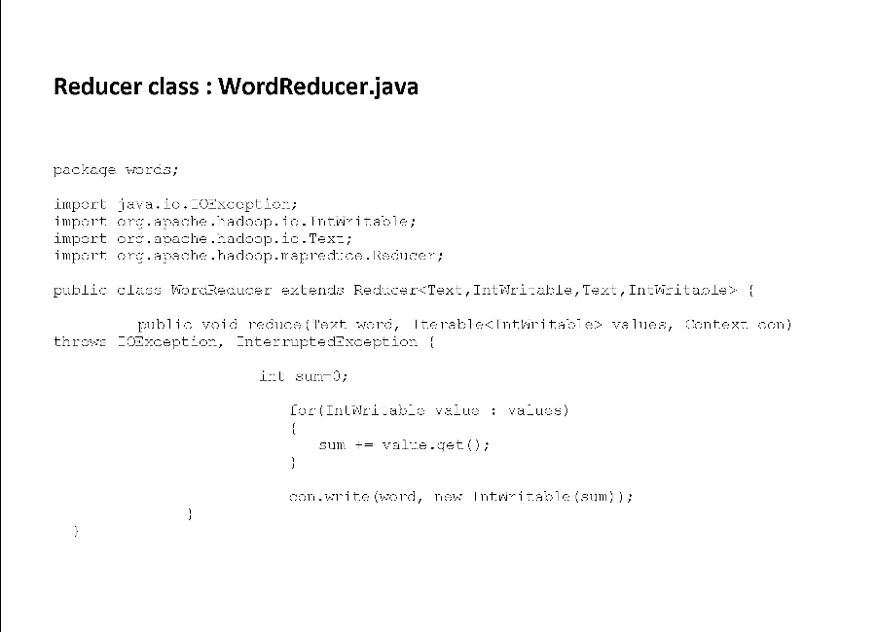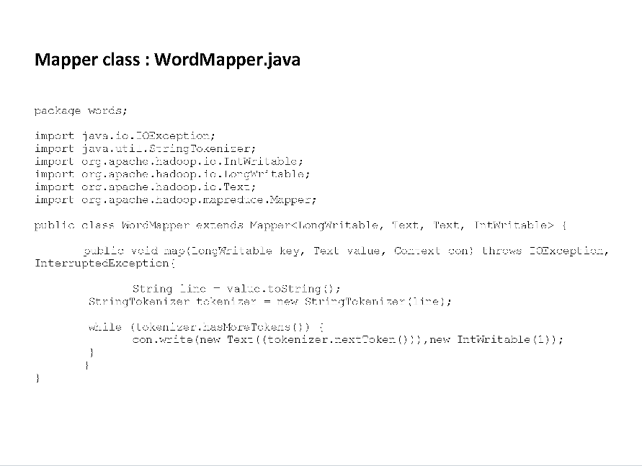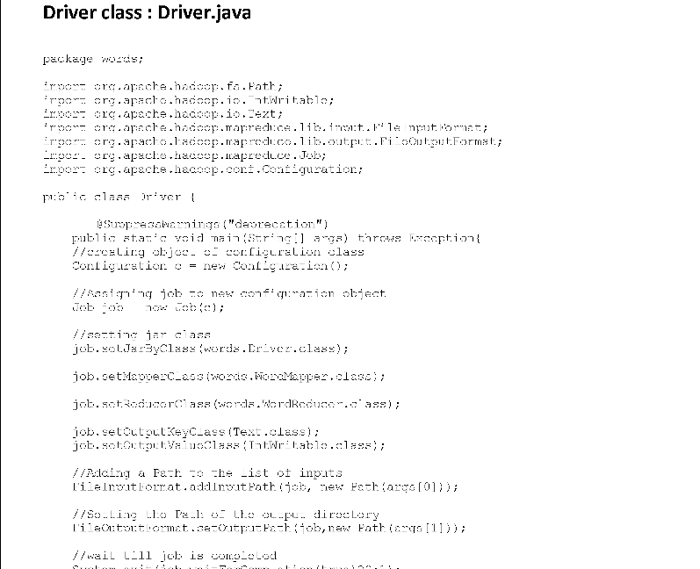



**Output :**

**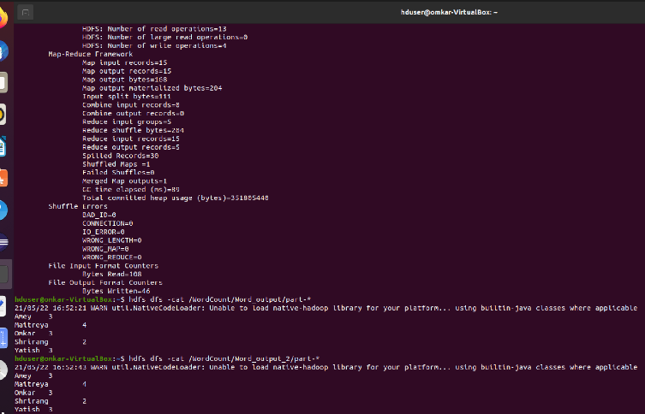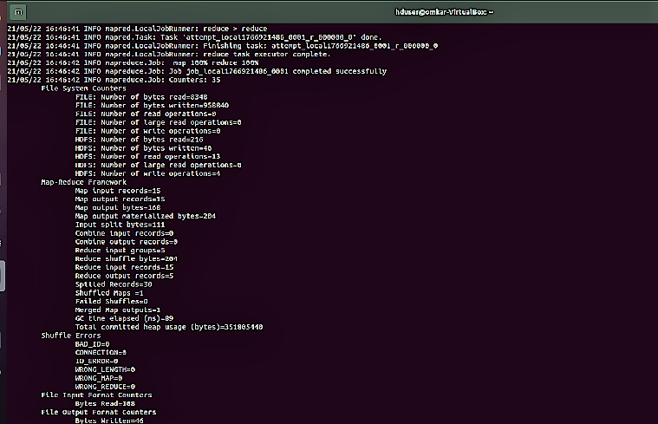**



**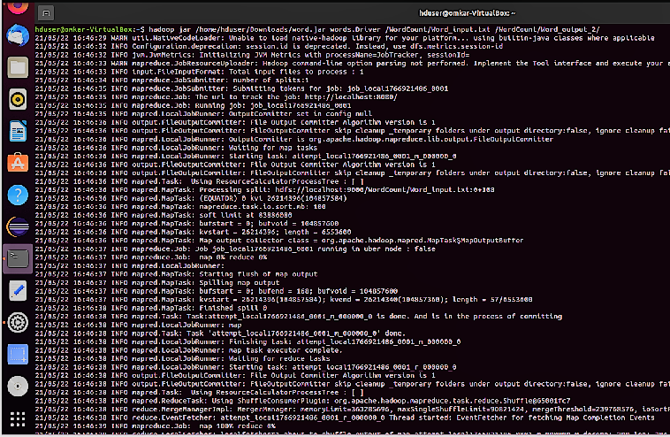**

### Conclusion:

Thus program using mareduce is implemented.

## Assignment No: 3

**Title:** Design and develop a distributed application to find the coolest/hottest year from the available weather data. Use weather data from the Internet and process it using MapReduce.

### Learning Objectives:

**Problem Statement:**

Study and perform program using map reduce on Hadoop.

**Learning Outcome**: Students will able to

* Implement map reduce program

### Software and Hardware Requirement:

* PC with Ubuntu and Hadoop installed.

### Theory:

**Implementation Steps:**

1. Create folder Data on Desktop and copy all given files
   1. Temp data csv file
   2. MaxTemperatureDriver.java : Manages input and output from Mapper and Reducer
   3. MaxTemperatureMapper.java : Reads input file
   4. MaxTemperatureReducer.java : Reads the input from mapper file)
2. su – hduser (Change the user)
3. sudo mkdir Temperature (Create folder Temperature)
4. sudo chmod -R 777 Temperature/
5. sudo chown -R hduser Temperature/
6. cd Temperature
7. pwd (Check path , It should be /home/hduser/Temperature )
8. copy the contents of Data folder into Temperature folder using command

sudo cp -R /home/ll01/Desktop/data/\* ./

1. Give permissions using

sudo chmod +r \*.\*

1. export CLASSPATH="/usr/local/hadoop/share/hadoop/mapreduce/hadoop-mapreduce- client-core-2.9.0.jar:/usr/local/hadoop/share/hadoop/mapreduce/hadoop-mapreduce-client- common-2.9.0.jar:/usr/local/hadoop/share/hadoop/common/hadoop-common- 2.9.0.jar:~/Temperature/MaxMinTemp/\*:/usr/local/hadoop/lib/\*"

(above command is available in file: hadoop-mapreduce-example-file.txt)

1. javac -d . MaxTemperatureMapper.java MaxTemperatureReducer.java MaxTemperatureDriver.java
2. cd MaxMinTemp/
3. ls (It should show class files)

sudo gedit Manifest.txt

1. Add following line and press enter and save the file Main-Class: MaxMinTemp.MaxTemperatureDriver
2. jar -cfm temperature.jar Manifest.txt MaxMinTemp/\*.class
3. cd
4. start-dfs.sh OR /usr/local/hadoop/sbin/start-dfs.sh
5. Start-yarn.sh OR /usr/local/hadoop/sbin/start-yarn.sh
6. jps
7. /usr/local/hadoop/bin/hdfs dfs -put /home/hduser/Temperature/input-dataset /
8. cd Temperature/
9. /usr/local/hadoop/bin/hadoop jar temperature.jar /input-dataset /output-temperature
10. /usr/local/hadoop/bin/hdfs dfs -cat /output-temperature/\*

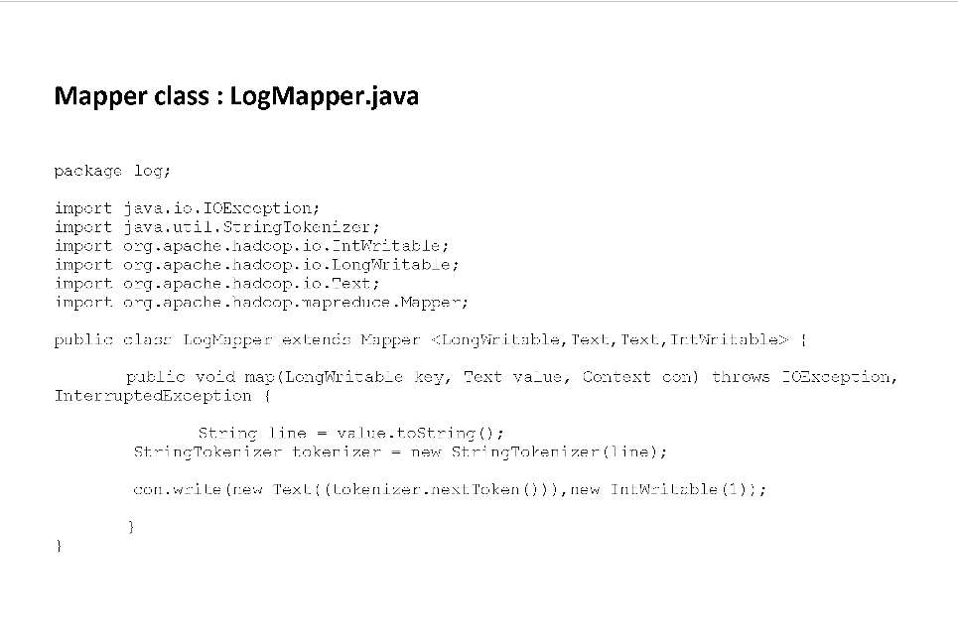

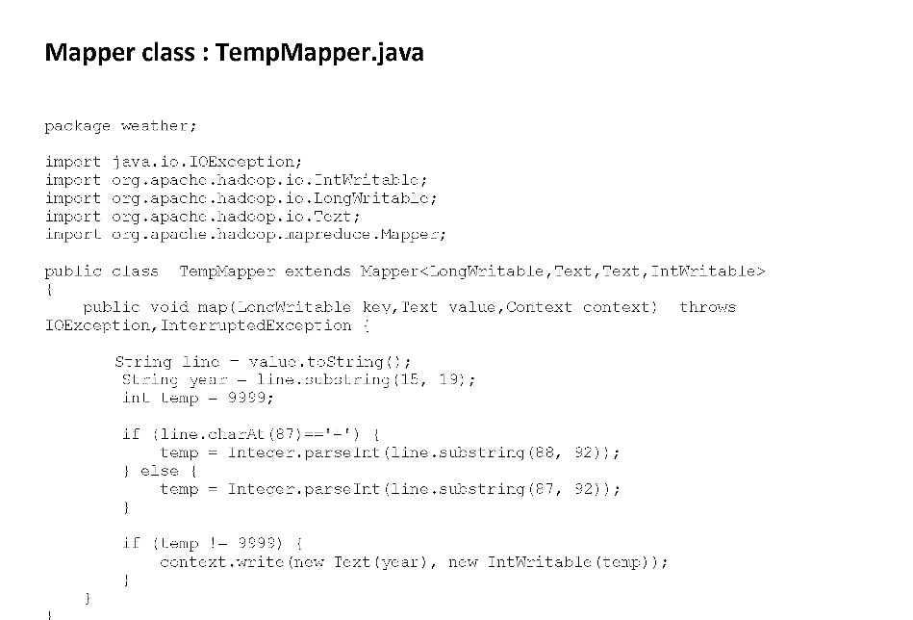

### Screenshot (736)Screenshot (737)

### Conclusion:

Thus program using mareduce is implemented.

## Assignment No: 4

**Title:** Write an application using HBase and HiveQL for flight information system which will include

1. Creating, Dropping, and altering Database tables
2. Creating an external Hive table to connect to the HBase for Customer Information Table
3. Load table with data, insert new values and field in the table, Join tables with Hive
4. Create index on Flight information Table
5. Find the average departure delay per day in 2008.

### Learning Objectives:

**Problem Statement:**

Study and perform database query on HBase and Hive.

**Learning Outcome**: Students will able to

* Performe database query

### Software and Hardware Requirement:

* PC with Ubuntu and Hadoop, Hbase and Hive installed.

### Theory:

**What is HBase?**

HBase is a data model that is similar to Google’s big table designed to provide quick random access to huge amounts of structured data. HBase is a distributed column-oriented database built on top of the Hadoop file system. It is an open-source project and is horizontally scalable.

HBase is a data model that is similar to Google’s big table designed to provide quick random access to huge amounts of structured data. It leverages the fault tolerance provided by the Hadoop File System (HDFS). It is a part of the Hadoop ecosystem that provides random real- time read/write access to data in the Hadoop File System. One can store the data in HDFS either directly or through HBase. Data consumer reads/accesses the data in HDFS randomly using HBase. HBase sits on top of the Hadoop File System and provides read and write access.

|  |  |  |  |
| --- | --- | --- | --- |
| **DEPARTMENT OF INFORMATION TECHNOLOGY** | | | |
|  | **HDFS** | **HBase** |  |
| HDFS is a distributed file system suitable for storing large files. | HBase is a database built on top of the HDFS. |
| HDFS does not support fast individual record lookups. | HBase provides fast lookups for larger tables. |
| It provides high latency batch processing; no concept of batch processing. | It provides low latency access to single rows from billions of records (Random access). |
| It provides only sequential access of data. | HBase internally uses Hash tables and provides random access, and it stores the data in indexed HDFS files for faster lookups. |
|  | HBase is a **column-oriented database** and the tables in it are sorted by row. The table schema defines only column families, which are the key value pairs. A table have multiple column families and each column family can have any number of columns. Subsequent column values are stored contiguously on the disk. Each cell value of the table has a timestamp. In short, in an HBase:  Table is a collection of rows. | | |
| AISSMS IOIT, Department of Information Technology Page 43 | | | |



Row is a collection of column families. Column family is a collection of columns. Column is a collection of key value pairs.

### Features of HBase

HBase is linearly scalable.

has automatic failure support.



It

provides consistent read and writes.



It

integrates with Hadoop, both as a source and a destination.



It

has easy java API for client.



It

It provides data replication across clusters. Where to Use HBase

Apache HBase is used to have random, real-time read/write access to Big Data.

hosts very large tables on top of clusters of commodity hardware.



It

Apache HBase is a non-relational database modeled after Google's Bigtable. Bitable acts up on Google File System, likewise Apache HBase works on top of Hadoop and HDFS.

### Applications of HBase

is used whenever there is a need to write heavy applications.



It

HBase is used whenever we need to provide fast random access to available data.

Companies such as Facebook, Twitter, Yahoo, and Adobe use HBase internally.

### What is Hive?

Hive is a data warehouse infrastructure tool to process structured data in Hadoop. It resides on top of Hadoop to summarize Big Data, and makes querying and analyzing easy.

Initially Hive was developed by Facebook, later the Apache Software Foundation took it up and developed it further as an open source under the name Apache Hive. It is used by different companies. For example, Amazon uses it in Amazon Elastic MapReduce.

**Hive is not**

A relational database

design for OnLine Transaction Processing (OLTP)



A

language for real-time queries and row-level updates



A

### Features of Hive

stores schema in a database and processed data into HDFS.



It

is designed for OLAP.



It

provides SQL type language for querying called HiveQL or HQL.



It

is familiar, fast, scalable, and extensible.



It

### Architecture of Hive

The following component diagram depicts the architecture of Hive:

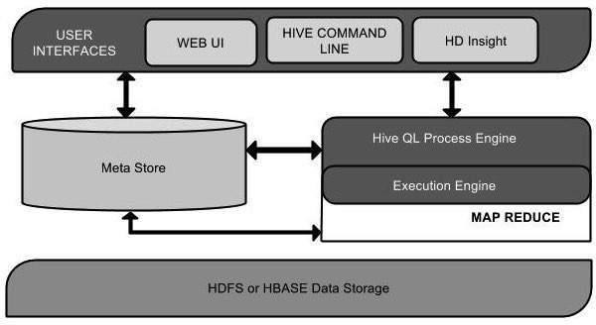



**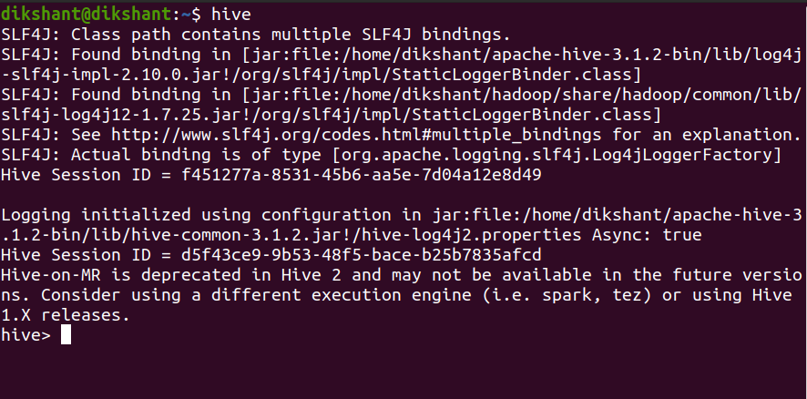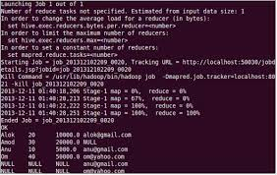**



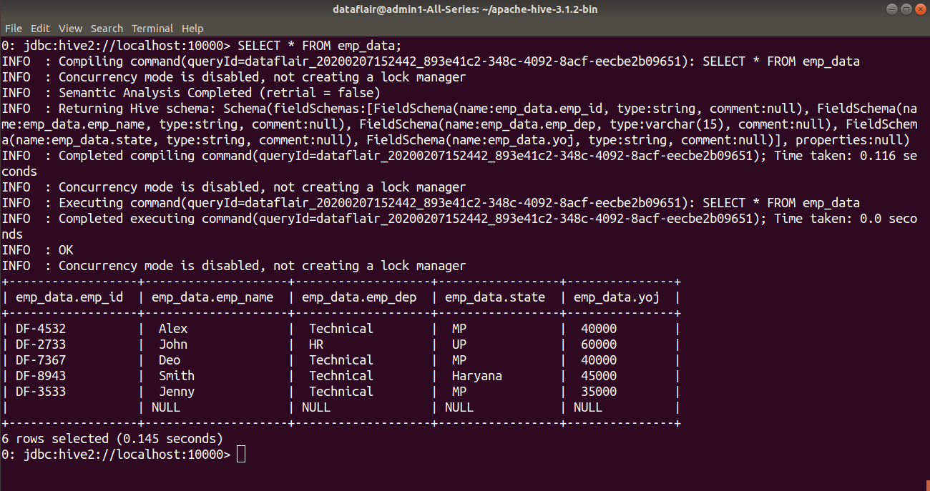

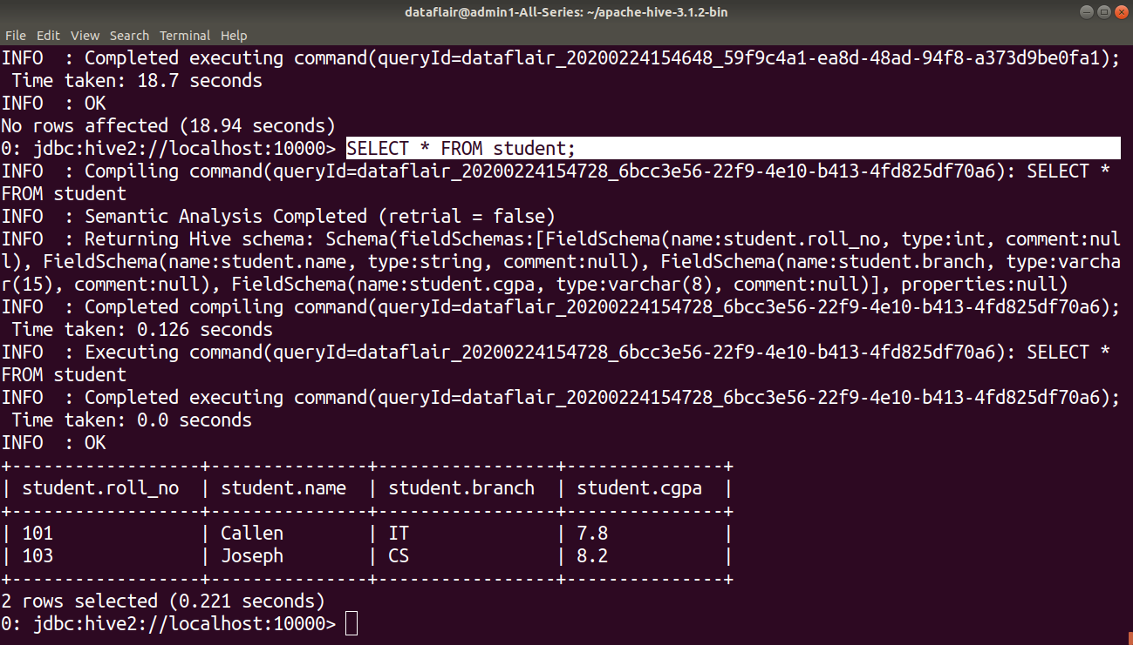



**Conclusion:** Database query performed on Hive and HBase.

## Assignment No: 5

**Title:** Perform the following operations using R/Python on the Amazon book review and Facebook metrics data sets

1) Create data subsets 2) Merge Data 3) Sort Data

4) Transposing Data 5) Melting Data to long format 6) Casting data to wide format

### Learning Objectives:

**Problem Statement:**

Study and perform different operations on dataset.

**Learning Outcome**: Students will able to

* Perform different operations on datase

### Software and Hardware Requirement:

* PC with Ubuntu , R and R Stdio installed.

### Theory:

**What is R?**

R is a programming language and software environment for statistical analysis, graphics representation and reporting. This programming language was named R, based on the first letter of first name of the two R authors (Robert Gentleman and Ross Ihaka), and partly a play on the name of the Bell Labs Language S.

### Loading Data into R:

To load a csv file into R, following syntax is used:

data < read.csv("input.csv")

### Creating Subsets in R:

To create a subset of data, we use the following syntax:

subset(x, subset, select, drop = FALSE, ...)

Return subsets of vectors, matrices or data frames which meet conditions.

*Arguments:*

**x**: object to be subsetted.

**subset**: logical expression indicating elements or rows to keep: missing values are taken as false.

**select**: expression, indicating columns to select from a data frame.

**drop**: passed on to ‘[’ indexing operator.

...: further arguments to be passed to or from other methods.

Example: subset(airquality, Temp > 80, select = c(Ozone, Temp))

### Merging Data in R:

Merge two data frames by common columns or row names, or do other versions of database

\_join\_ operations

merge(x, y, by = intersect(names(x), names(y)),

by.x = by, by.y = by, all = FALSE, all.x = all, all.y = all,

*Arguments:*

**x, y:** data frames, or objects to be coerced to one.

**by, by.x, by.y:** specifications of the columns used for merging.

**all:** logical; ‘all = L’ is shorthand for ‘all.x = L’ and ‘all.y =L’, where ‘L’ is either ‘TRUE’ or ‘FALSE’.

**all.x:** logical; if ‘TRUE’, then extra rows will be added to the output, one for each row in ‘x’ that has no matching row in ‘y’. These rows will have ‘NA’s in those columns that are usually filled with values from ‘y’. The default is ‘FALSE’, so that only rows with data from both ‘x’ and ‘y’ are included in the output.

**all.y:** logical; analogous to ‘all.x’.

**sort:** logical. Should the result be sorted on the ‘by’ columns?

**suffixes:** a character vector of length 2 specifying the suffixes to be used for making unique the names of columns in the result which not used for merging (appearing in ‘by’ etc).

**incomparables:** values which cannot be matched.

...: arguments to be passed to or from methods.

### Example:

## use character columns of names to get sensible sort order

authors <- data.frame(surname = I(c("Tukey", "Venables", "Tierney", "Ripley", "McNeil")), nationality = c("US", "Australia", "US", "UK", "Australia"), deceased = c("yes", rep("no", 4)))

books <- data.frame(name = I(c("Tukey", "Venables", "Tierney", "Ripley", "Ripley", "McNeil", "R Core")), title = c("Exploratory Data Analysis", "Modern Applied Statistics ...", "LISP-STAT", "Spatial Statistics", "Stochastic Simulation", "Interactive Data Analysis", "An Introduction to R"),other.author = c(NA, "Ripley", NA, NA, NA, NA, "Venables & Smith"))

### (m1 <- merge(authors, books, by.x = "surname", by.y = "name")) (m2 <- merge(books, authors, by.x = "name", by.y = "surname"))

1. **Sorting Data in R:**

### Sort (or order) a vector or factor: Syntax:

sort(x, decreasing = FALSE, na.last = NA, ...)

*Arguments*:

**x:** for ‘sort’ an R object with a class or a numeric, complex, character or logical vector.

**decreasing:** logical. Should the sort be increasing or decreasing?

**na.last:** for controlling the treatment of ‘NA’s. If ‘TRUE’, missing values in the data are put last; if ‘FALSE’, they are put first; if ‘NA’, they are removed.

Examples: require(stats)

x <- swiss$Education[1:25]

x; sort(x); sort(x, partial = c(10, 15))

### Sort a data frame:

‘order’ returns a permutation which rearranges its first argument into ascending or descending order, breaking ties by further arguments. ‘sort.list’ is the same, using only one argument.

### Syntax:

order(..., na.last = TRUE, decreasing = FALSE)

sort.list(x, partial = NULL, na.last = TRUE, decreasing = FALSE, method = c("shell", "quick", "radix"))

*Arguments:*

**...:** a sequence of numeric, complex, character or logical vectors, all of the same length, or a classed R object.

**x:** an atomic vector.

**partial:** vector of indices for partial sorting. (Non-‘NULL’ values are not implemented.)

**decreasing:** logical. Should the sort order be increasing or decreasing?

**na.last:** for controlling the treatment of ‘NA’s. If ‘TRUE’, missing values in the data are put last; if ‘FALSE’, they are put first; if ‘NA’, they are removed (see ‘Note’.)

**method:** the method to be used: partial matches are allowed. The default is ‘"shell"’ except for some special cases

### Transposing Data in R:

The transpose (reversing rows and columns) is perhaps the simplest method of reshaping a dataset. Use the t() function to transpose a matrix or a data frame. In the latter case, row names become variable (column) names.

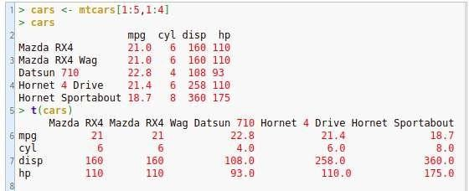

### Melting & Casting in R:

When using R, consider the words wide and long as visual metaphors for the shape of your data. In other words, wide data tends to have more columns and fewer rows compared to long data. The reshape package extends this metaphor by using the terminology of melt and cast:

* To convert wide data to long, you melt it with the melt() function.
* To convert long data to wide, you cast it with the dcast() function for data frames or the acast() function for arrays.

The melt function takes data in wide format and stacks a set of columns into a single column of data. To make use of the function we need to specify a data frame, the id variables (which will be left at their settings) and the measured variables (columns of data) to be stacked. The default assumption on measured variables is that it is all columns that are not specified as id variables.

Ex:

p

|  |  |  |  |  |
| --- | --- | --- | --- | --- |
| ty | e | year | period | service incidents |

|  |  |  |  |  |  |  |  |  |
| --- | --- | --- | --- | --- | --- | --- | --- | --- |
|  | 1 | A | 60 | 60 | 127 | 0 |  | |
|  | 2 | A | 60 | 75 | 63 | 0 |  | |
|  | 3 | A | 65 | 60 | 1095 | 3 |  | |
|  | 4 | A | 65 | 75 | 1095 | 4 |  |  |
| 5 | A | 70 | 60 | 1512 | 6 |  |
|  | 6 | A | 70 | 75 | 3353 | 18 |  |  |
|  | 7 | A | 75 | 60 | 0 | 0 |  |  |
|  | 8 | A | 75 | 75 | 2244 | 11 |  |  |
|  | 9 | B | 60 | 60 | 44882 | 39 |  |  |
|  | 10 | B | 60 | 75 | 17176 | 29 |  |  |
|  |  |  |  |  |  |  |  |  |

Now lets keep type and year as constant(id variable) and melt (stack) the other three variables namely period, service and incidents.

molten.ships <- melt(shipdata, id = c("type","year")) print(molten.ships)

As the result type and year column are kept constant. Columns named period, service and incidents are stacked under the column named variable and their values are stacked under the column named value. The result of melt function is shown below

type year variable value

1 A 60

2 A

3 A 60

4 A 65

5 A

6 A 65

period 60

period

period 75

period 60

period

period 75

1. A 70 period 60
2. A period

10 B 70 period 75

service

12 A

60

period

75

11 A

13 A 75 service 75

1. A
2. A
3. A
4. A
5. A
6. B
7. B
8. A
9. A
10. A

60

service

service service service service

service

60

60

75

60

127

60

65

incident

s incident s

63

0

0

65

3

1. A 70 incidents 6
2. A 70 incidents 18
3. A 75 incidents 0

|  |  |  |  |
| --- | --- | --- | --- |
| 28 A | 75 | incidents | 11 |
| 29 B | 60 | incidents | 39 |

30 B 60 incidents 29

### Cast Function in R:

Aggregation occurs when the combination of variables in the cast function does not identify Individual observations. In this case cast function reduces the multiple values to a single one by summing up the values in the value column. Cast function example is shown below

recasted.ship <- cast(molten.ships, type+year~variable,sum) print(recasted.ship)As the result cast function sums up the different variables for each type and year and those variables are casted back as columns and result is shown below.

|  |  |  |  |  |  |
| --- | --- | --- | --- | --- | --- |
| ty | pe | year | period | service incidents | |
| 1 | A | 60 | 135 | 190 | 0 |
| 2 | A | 65 | 135 | 2190 | 7 |
| 3 | A | 70 | 135 | 4865 | 24 |
| 4 | A | 75 | 135 | 2244 | 11 |
| 5 | B | 60 | 135 | 62058 | 68 |

For example Type A year 60 has two periods 60 and 75. This is summed up and result 135 is recorded under the column name period with the help of cast function.

**Conclusion:** Thus different operation using R is performed on given dataset.

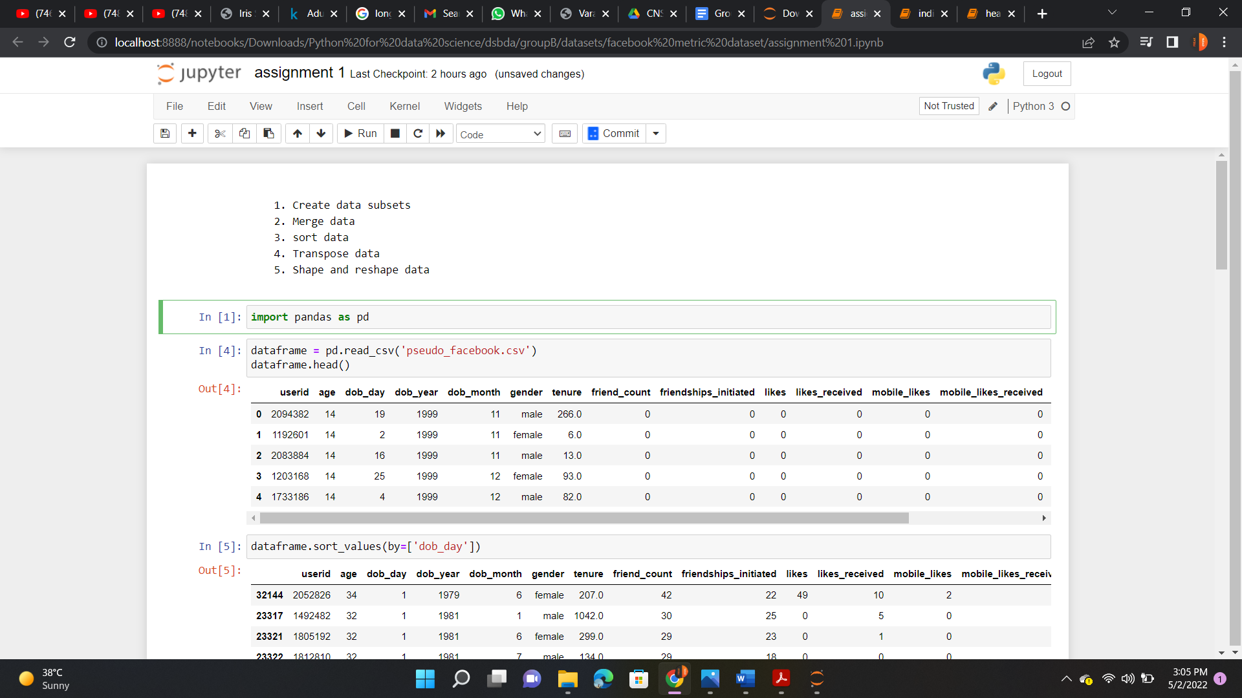



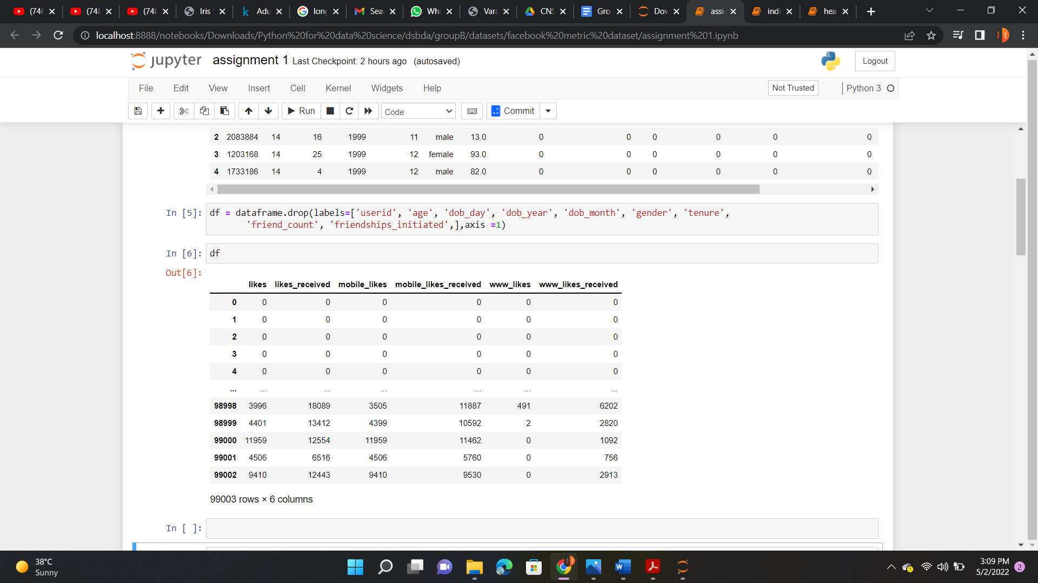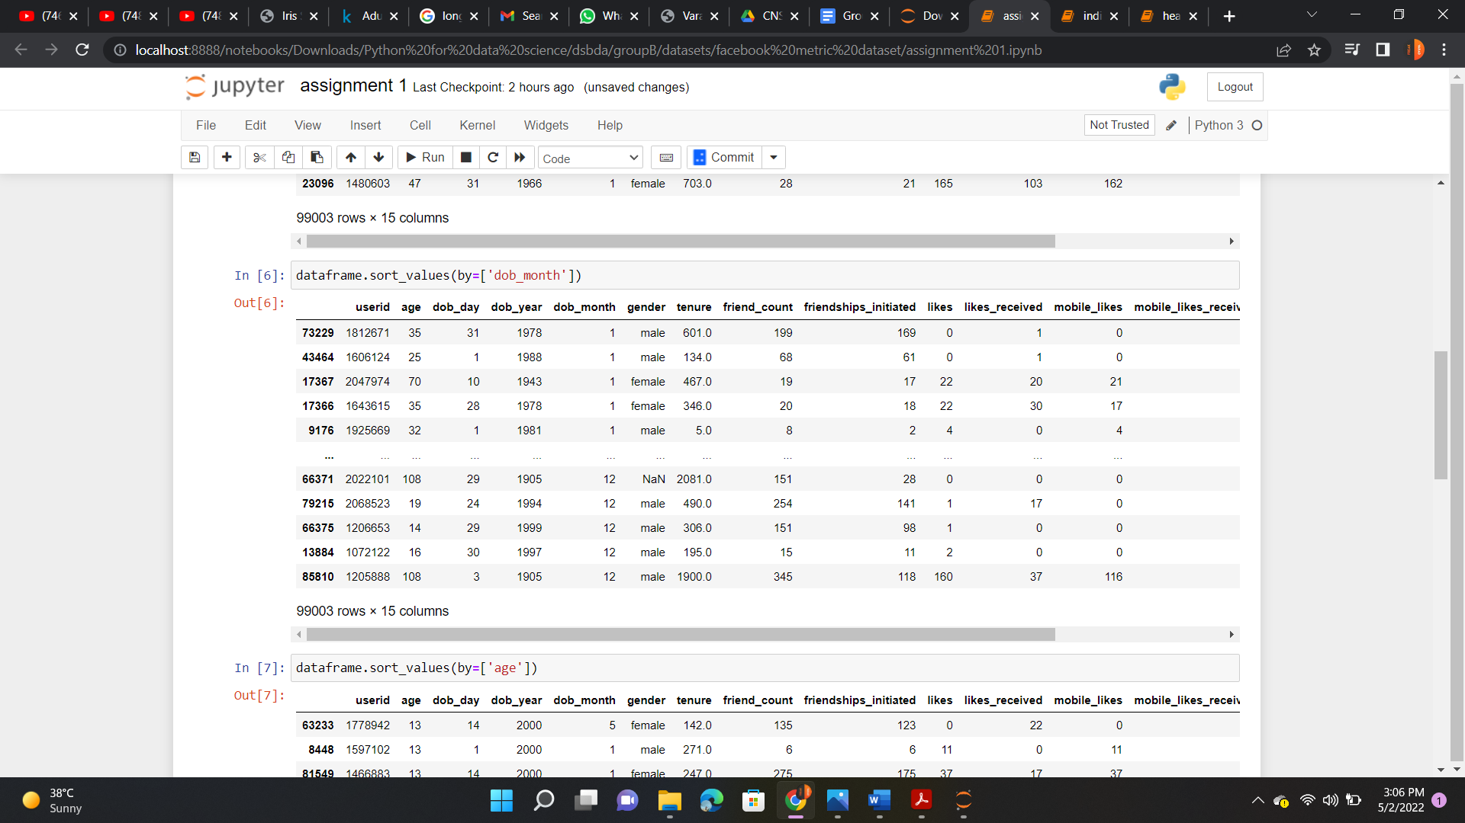

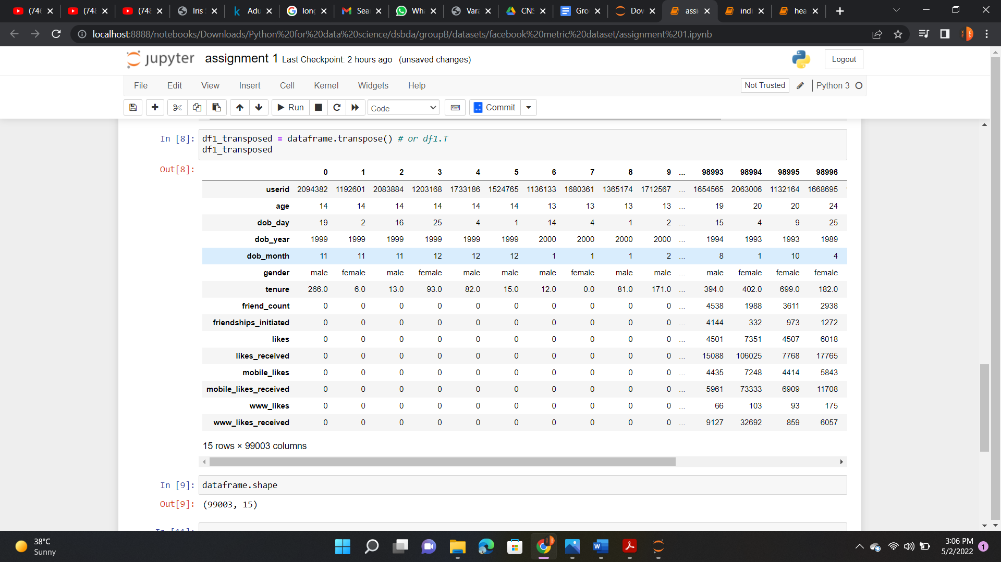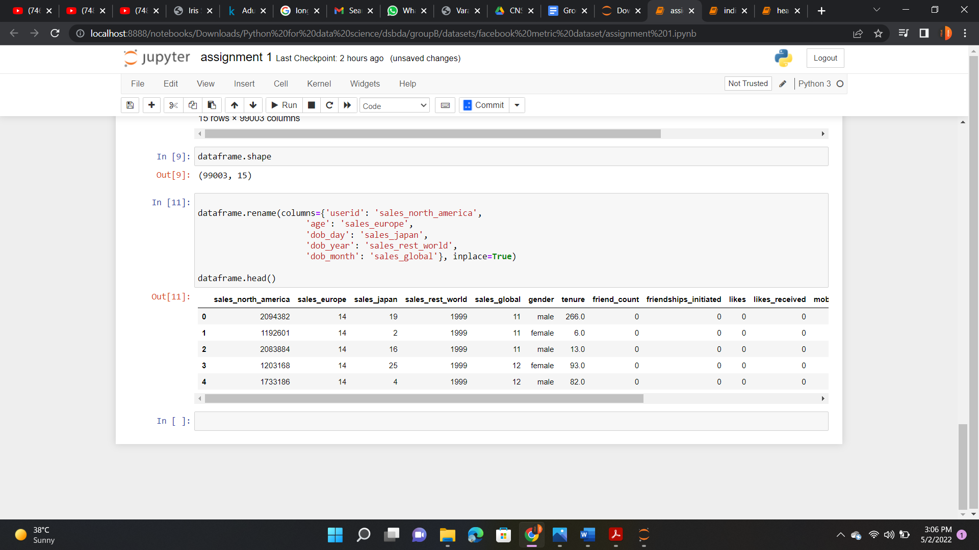

## Assignment No: 6

**Title:** Perform the following operations using R/Python on the Air quality and Heart Diseases data sets

1) Data Cleaning 2) Data Integration 3) Data Transformation

4) Error Correcting 5) Data Model Building

### Learning Objectives:

**Problem Statement:**

Study and perform different operations on dataset.

**Learning Outcome**: Students will able to

* Perform different operations on datase

### Software and Hardware Requirement:

* PC with Ubuntu , R and R Stdio installed.

### Theory:

**Data Cleaning** is the process of detecting and correcting (or removing) corrupt or inaccurate records from a record set, table, or database and refers to identifying incomplete, incorrect, inaccurate or irrelevant parts of the data and then replacing, modifying, or deleting the dirty or coarse data.

### To eliminate missing values in R:

Missing data in R appears as NA. NA is not a string or a numeric value, but an indicator of missingness.

* **na.omit and na.exclude:** returns the object with observations removed if they contain any missing values; differences between omitting and excluding NAs can be seen in some prediction and residual functions
* **na.pass:** returns the object unchanged
* **na.fail:** returns the object only if it contains no missing values

### Data Transformation:

R provides a function to transform data

**Transform function**: Based closely on the standard R transform function. Unlike the R function, output is provided that provides feedback and guidance regarding the specified

transformation(s), and variable labels are accommodated. Existing variable labels are retained in the transformed data frame.

**Syntax:** Transform(data=mydata, quiet=getOption("quiet"), …)

*Arguments:*

**data:** The name of the data frame from which to create the subset, which is mydata by default.

**quiet**: If set to TRUE, no text output.

**…** : The list of transformations, each of the form, variable = equation. Each variable can be the name of an existing variable in the data frame or a newly created variable.

### Data Model Building:

**Stages of Predictive Modeling**

Predictive Modeling is the process of building a model to predict future outcomes using statistics techniques. In order to generate the model, historical data of prior occurrences needs to be analyzed, classified and validated.

### Listed below are the stages of predictive modeling:

1. Data Gathering and Cleansing
2. Data Analysis/Transformation
3. Building a Predictive Model
4. Inferences

### Applying KNN on heart disease dataset

1. Create Subsets for training and testing bu using following commands: trainingSet1 <- hdata[1:250,1:13]

testSet1 <- hdata[251:302,1:13] trainingOutcomes1 <- hdata[1:250, 14] testOutcomes1<- hdata[251:302, 14]

1. Apply the KNN function to create model:

predictions1 <- knn(train = trainingSet1, cl = trainingOutcomes1, k=8,test = testSet1)

1. Print the confusion matrix for the test set. table(testOutcomes1, predictions1)
2. Calculate the accuracy using the following command.

100\*sum(trainingOutcomes1==predictions1)/250

1. Air quality index

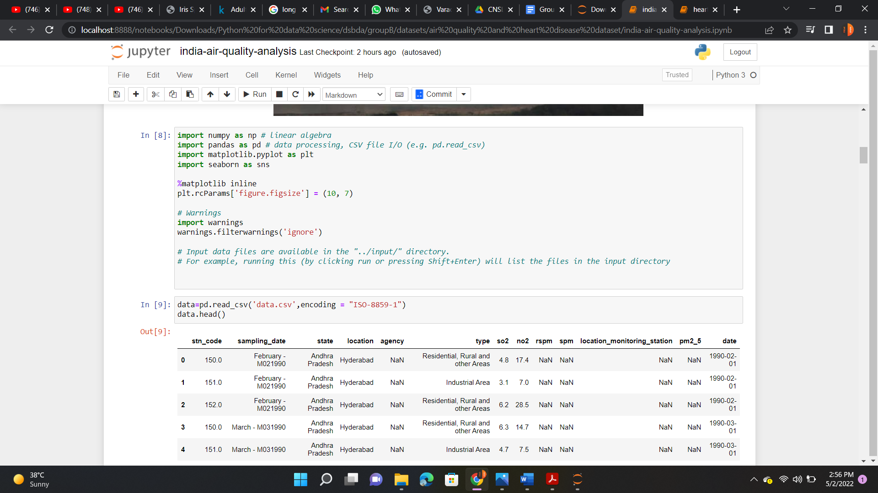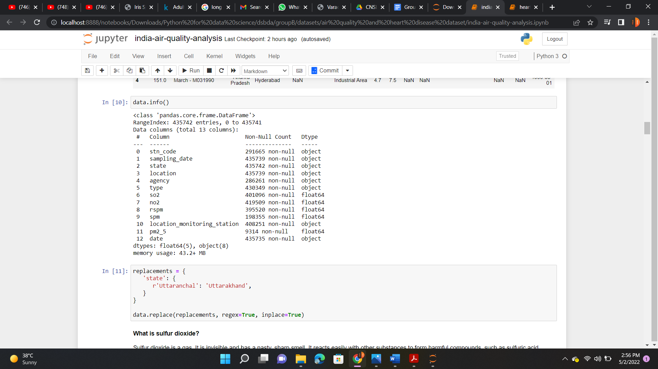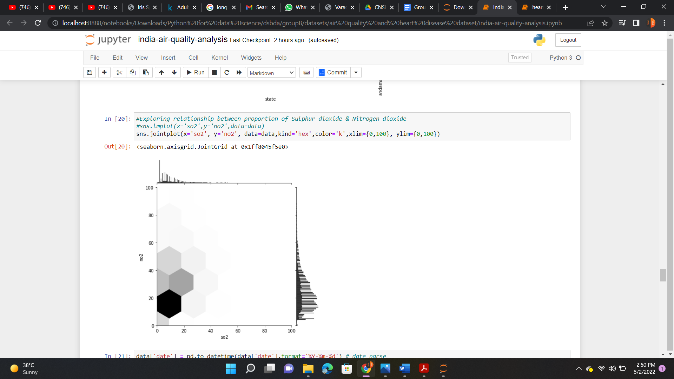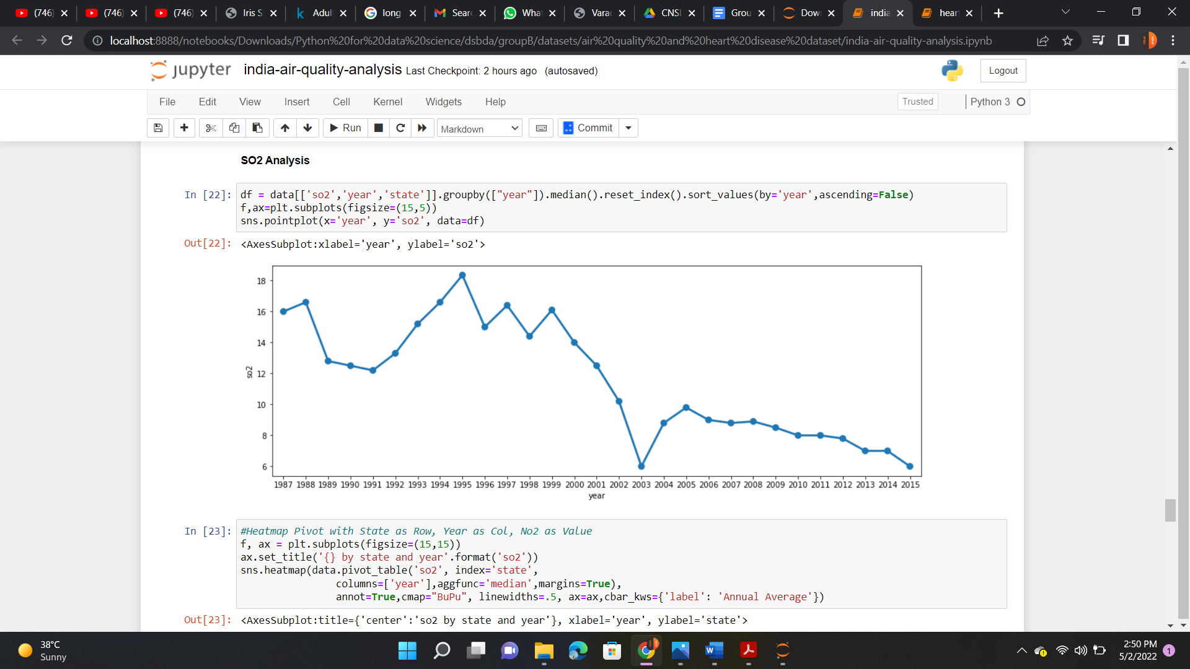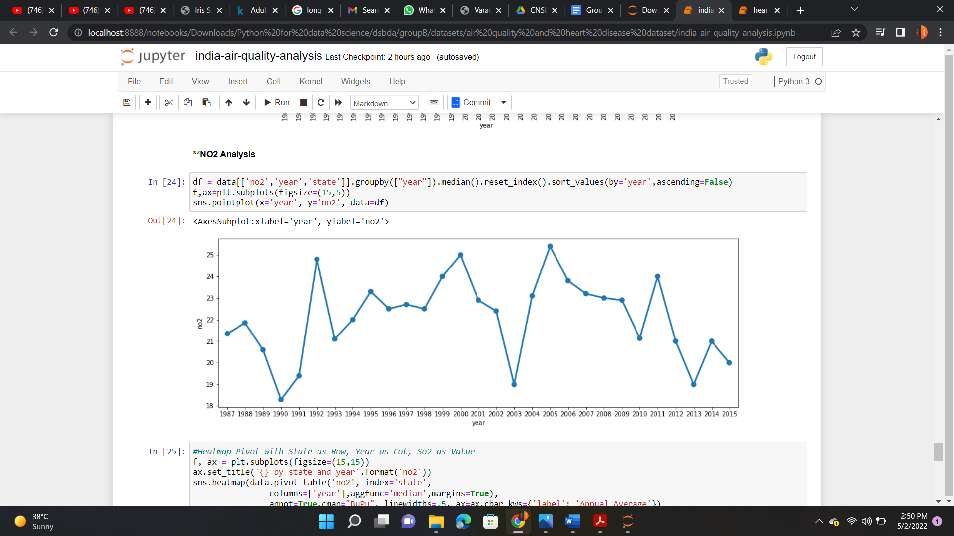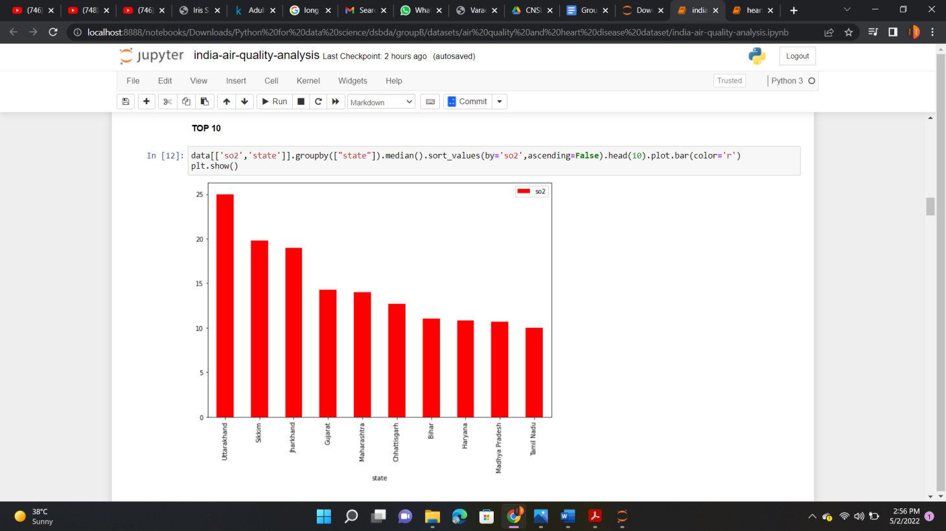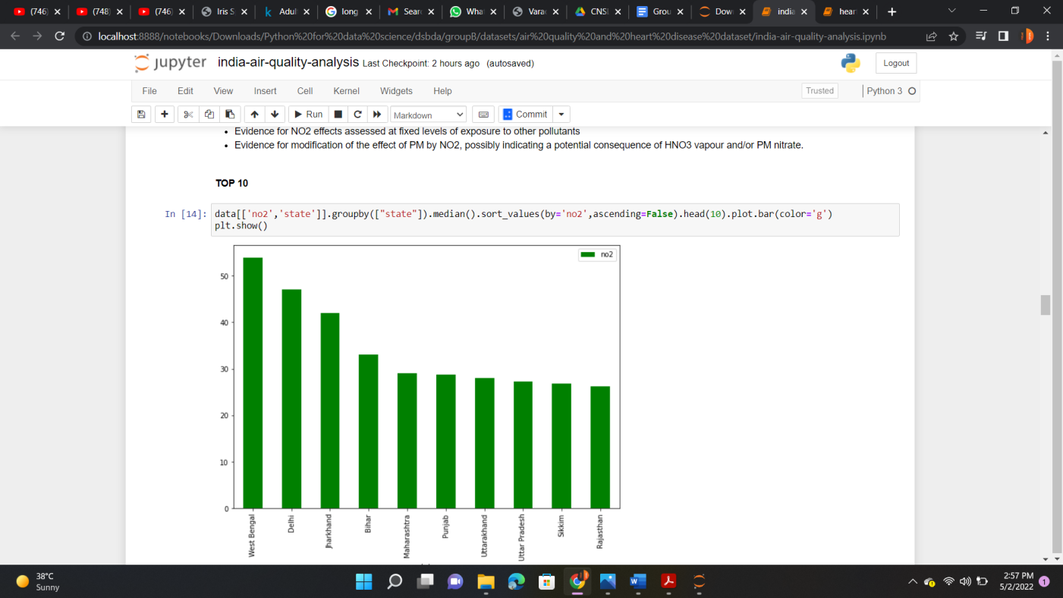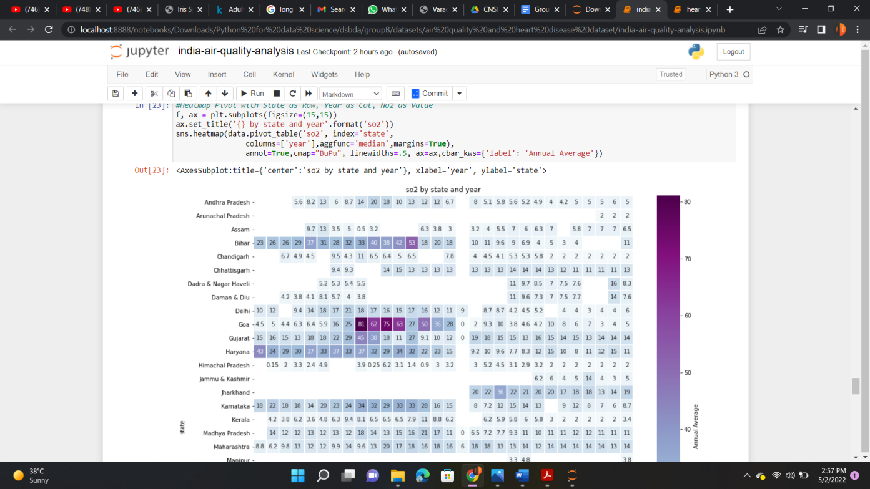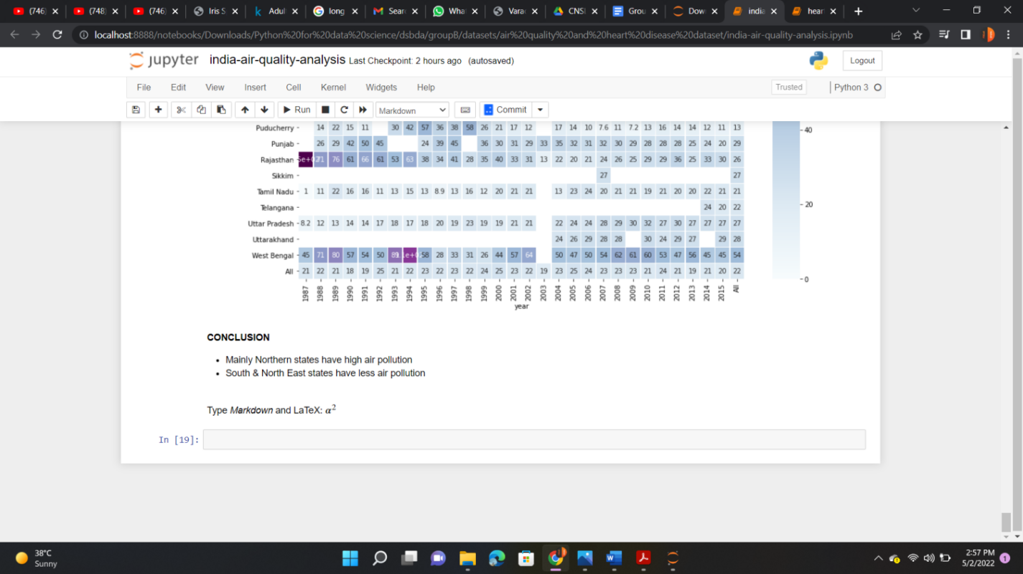

1. Heart Disease Dataset

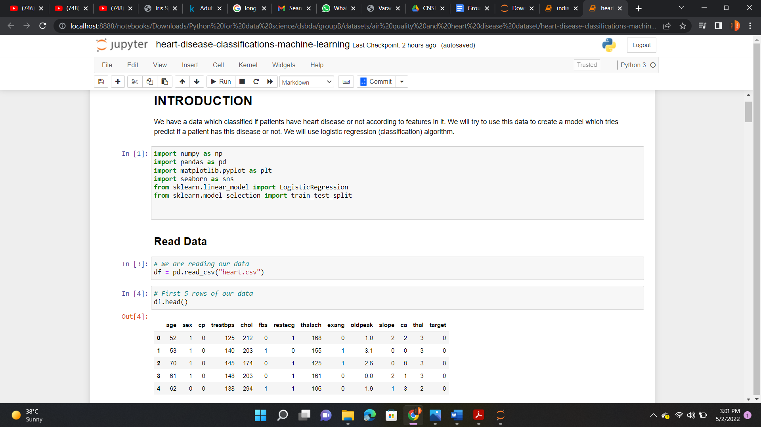



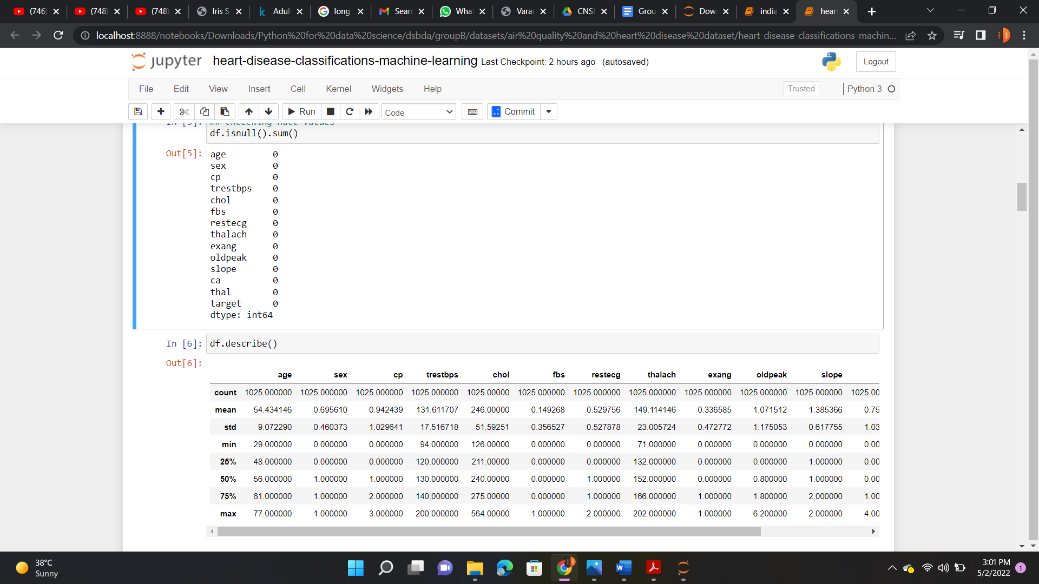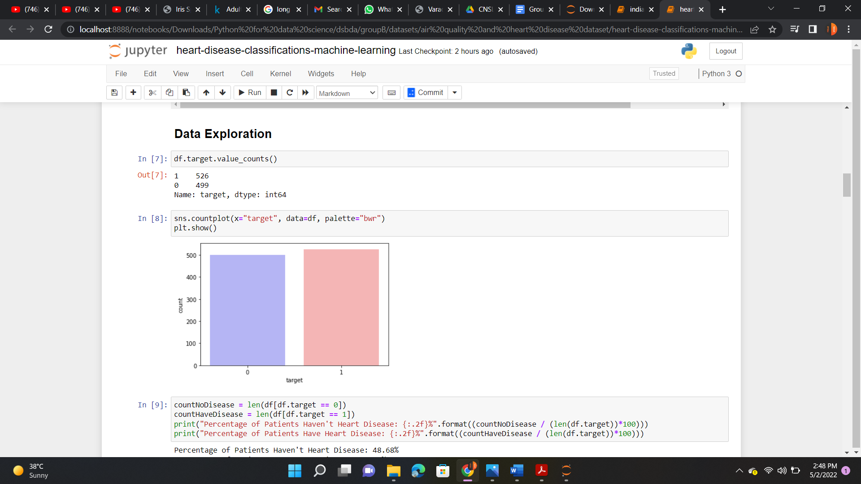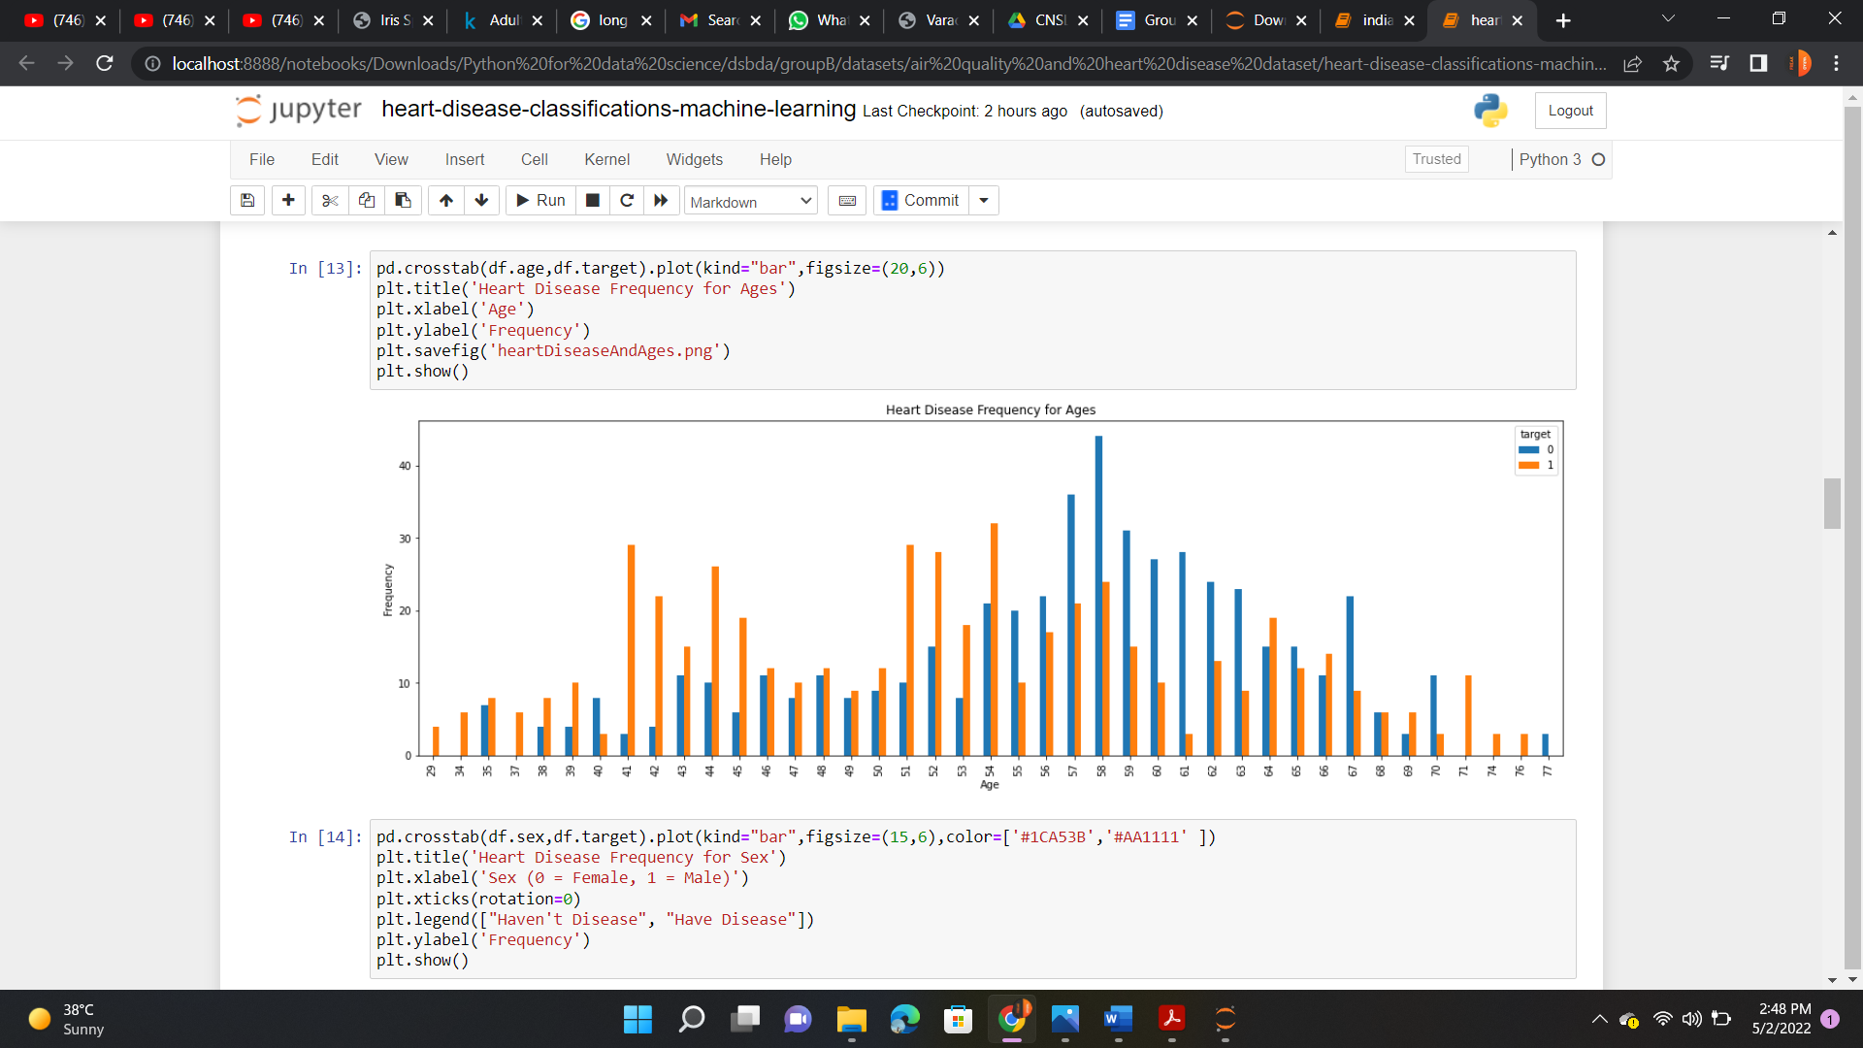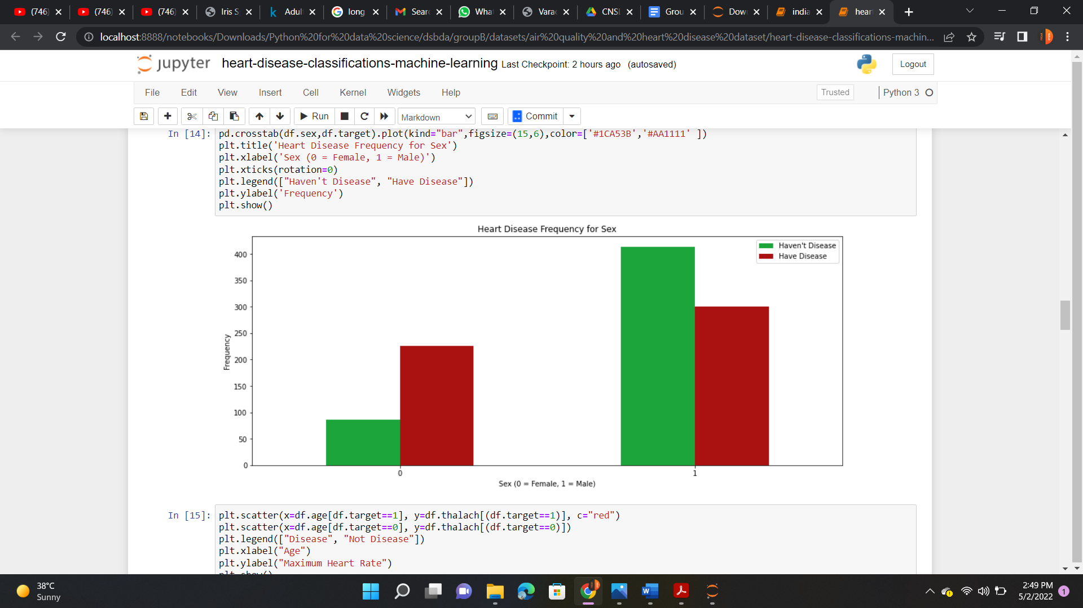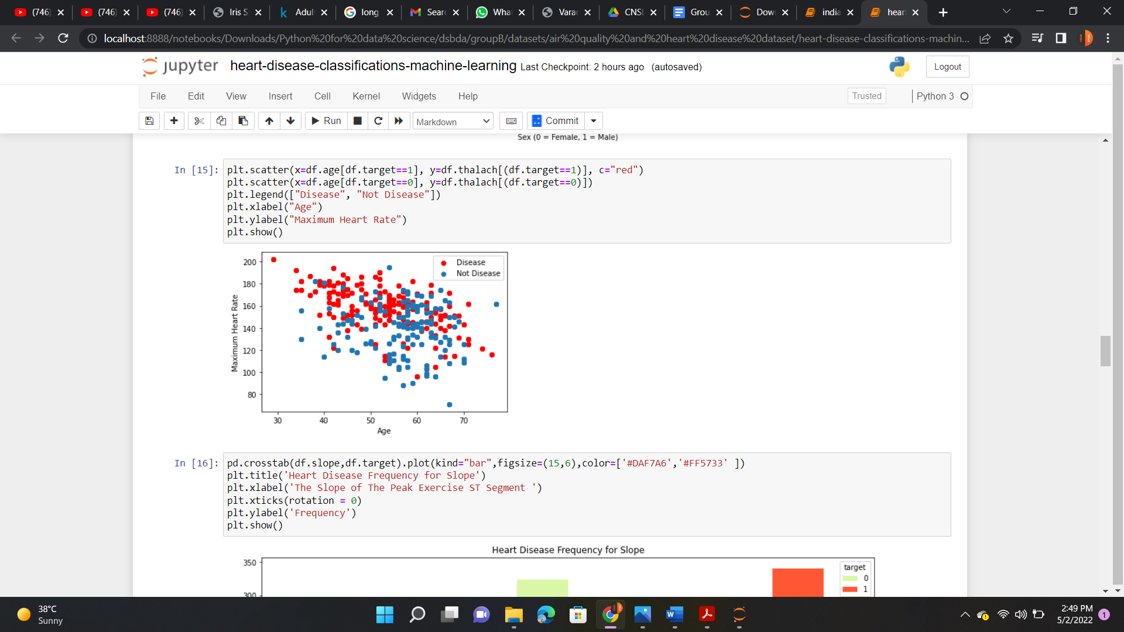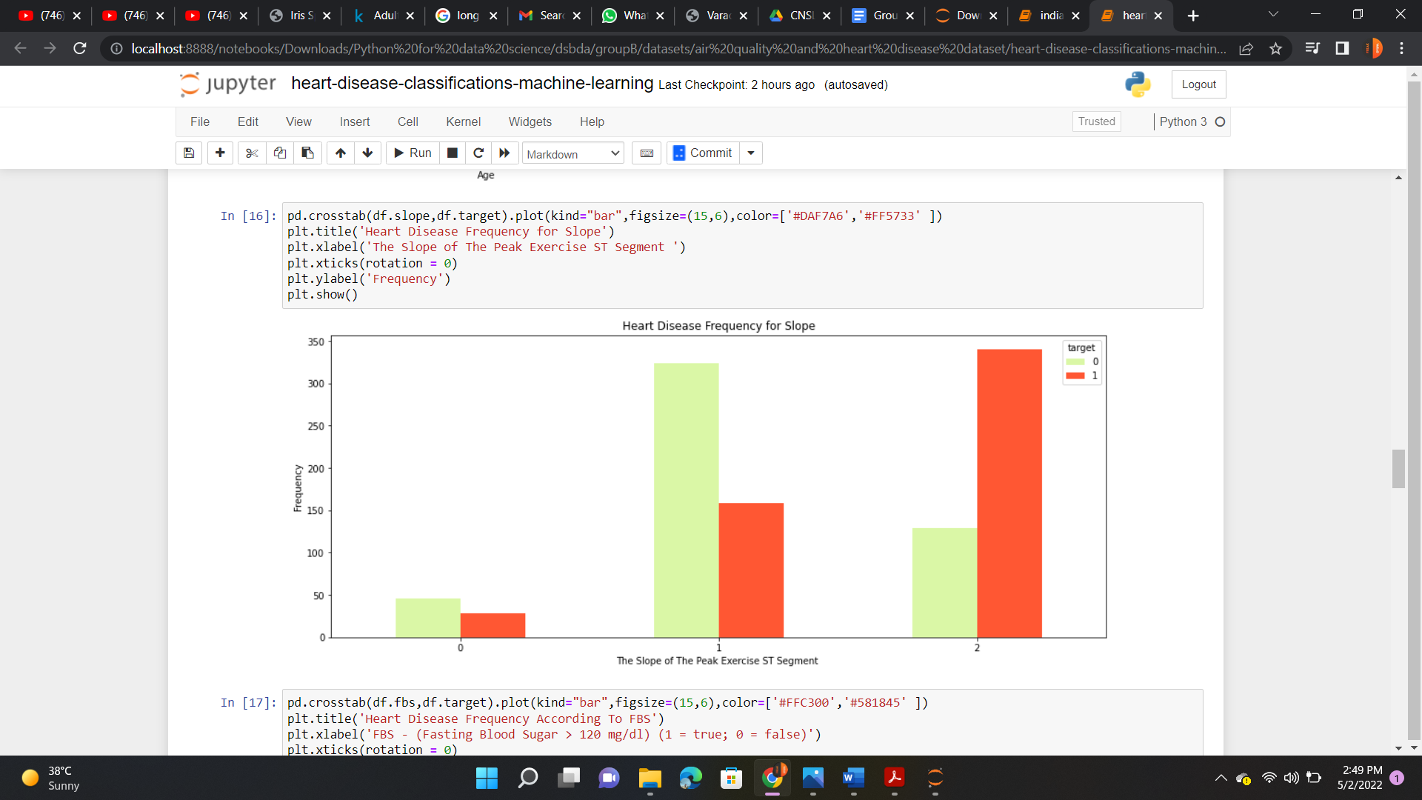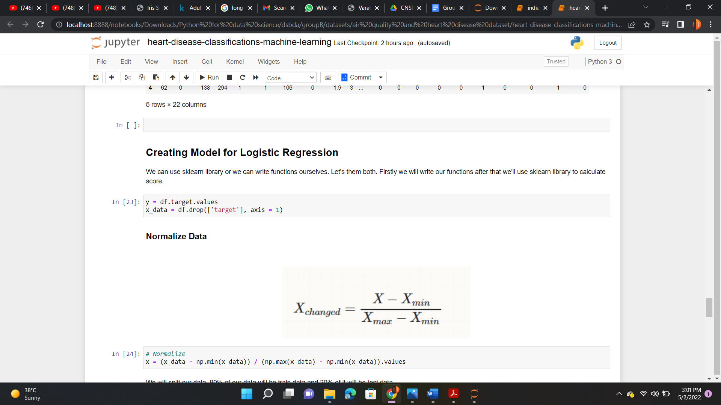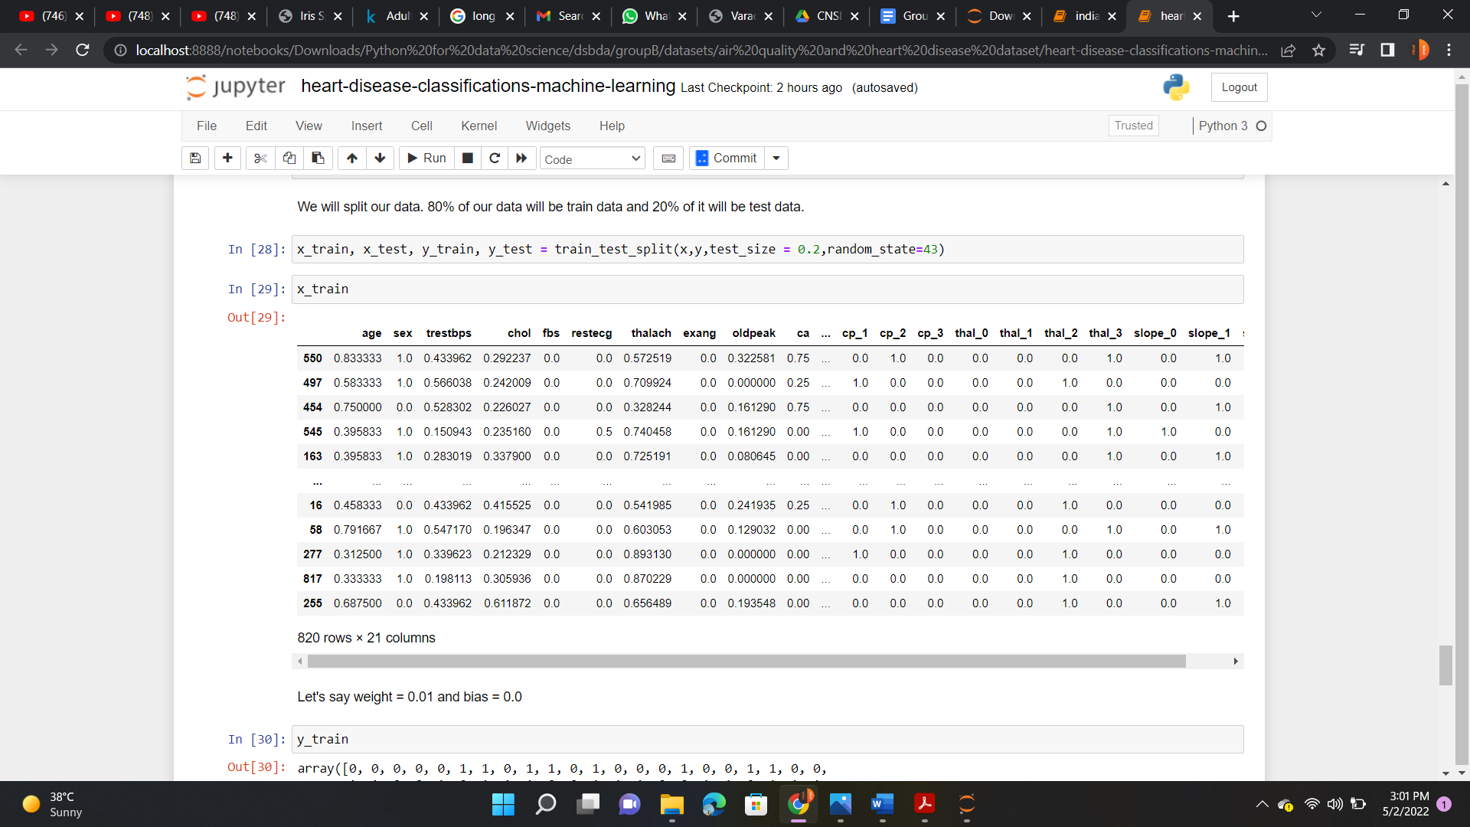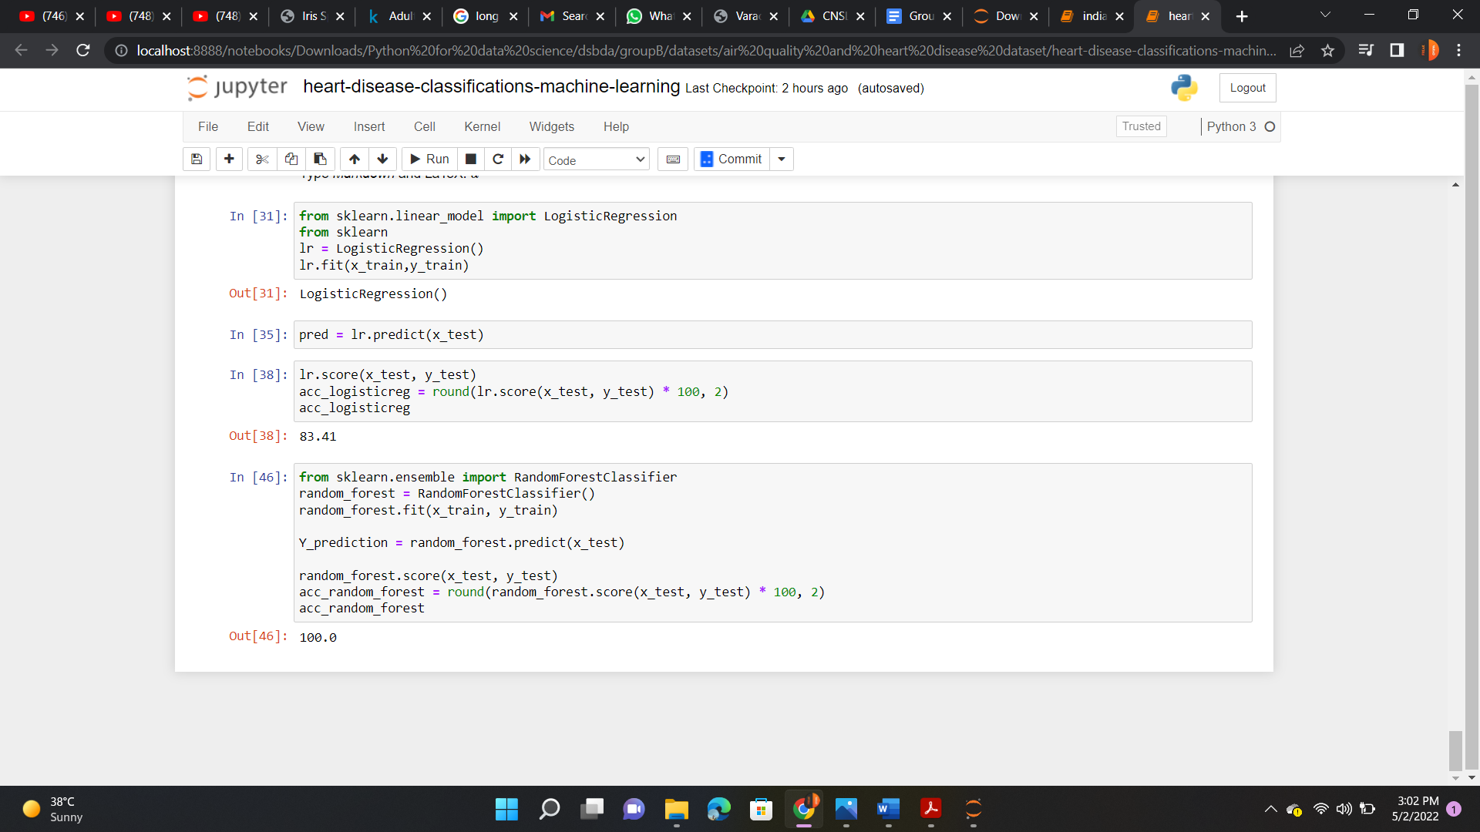

**Conclusion:** Thus Data Cleanin, Data Integration, Data Transformation, Error Correcting and Data Model Building operation in R is performed on given data set.

## Assignment No: 8

**Title:** Visualize the data using R/Python by plotting the graphs for assignment no. 6 and 7.

### Learning Objectives:

**Problem Statement:**

Perform visualization on dataset.

**Learning Outcome**: Students will able to

* Perform visualization on dataset.

### Software and Hardware Requirement:

* PC with Ubuntu , R and R Stdio installed.

### Theory:

One of the main reasons data analysts turn to R is for its strong graphic capabilities. Creating Graphs:

In R, graphs are typically created interactively.

# Creating a Graph attach(mtcars) plot(wt, mpg) abline(lm(mpg~wt))

title("Regression of MPG on Weight")

The plot( ) function opens a graph window and plots weight vs. miles per gallon. The next line of code adds a regression line to this graph. The final line adds a title



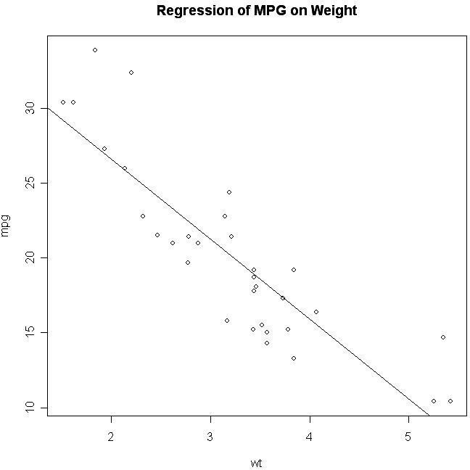

Other Basic Graphs:

The remainder of the section describes how to create basic graph types. These include density plots (histograms and kernel density plots), dot plots, bar charts (simple, stacked, grouped), line charts, pie charts (simple, annotated, 3D), boxplots (simple, notched, violin plots,

bagplots) and Scatterplots (simple, with fit lines, scatterplot matrices, high density plots, and 3D plots).

### Histograms

You can create histograms with the function hist(x) where x is a numeric vector of values to be plotted. The option freq=FALSE plots probability densities instead of frequencies. The option breaks= controls the number of bins.

# Simple Histogram hist(mtcars$mpg)

# Colored Histogram with Different Number of Bins hist(mtcars$mpg, breaks=12, col="red")



### Kernel Density Plots

Kernal density plots are usually a much more effective way to view the distribution of a variable. Create the plot using plot(density(x)) where x is a numeric vector.

# Kernel Density Plot

d <- density(mtcars$mpg) # returns the density data plot(d) # plots the results

# Filled Density Plot

d <- density(mtcars$mpg)

plot(d, main="Kernel Density of Miles Per Gallon") polygon(d, col="red", border="blue"

### Dot Plots

Create dotplots with the dotchart(x, labels=) function, where x is a numeric vector and labels is a vector of labels for each point. You can add a groups= option to designate a factor specifying how the elements of x are grouped. If so, the option gcolor= controls the color of the groups label. cex controls the size of the labels.

# Simple Dotplot

dotchart(mtcars$mpg,labels=row.names(mtcars),cex=.7,

main="Gas Milage for Car Models",

xlab="Miles Per Gallon")

# Dotplot: Grouped Sorted and Colored

# Sort by mpg, group and color by cylinder x <- mtcars[order(mtcars$mpg),] # sort by mpg x$cyl <- factor(x$cyl) # it must be a factor

x$color[x$cyl==4] <- "red" x$color[x$cyl==6] <- "blue" x$color[x$cyl==8] <- "darkgreen"

dotchart(x$mpg,labels=row.names(x),cex=.7,groups= x$cyl,

main="Gas Milage for Car Models\ngrouped by cylinder",

xlab="Miles Per Gallon", gcolor="black", color=x$color)

### Bar Plots

Create barplots with the barplot(height) function, where height is a vector or matrix. If height is a vector, the values determine the heights of the bars in the plot. If height is a matrix and the option beside=FALSE then each bar of the plot corresponds to a column of height, with the values in the column giving the heights of stacked “sub-bars”. If height is a matrix and beside=TRUE, then the values in each column are juxtaposed rather than stacked. Include option names.arg=(character vector) to label the bars. The option horiz=TRUE to createa a horizontal barplot

# Simple Bar Plot

counts <- table(mtcars$gear) barplot(counts, main="Car Distribution",

xlab="Number of Gears")

# Simple Horizontal Bar Plot with Added Labels counts <- table(mtcars$gear)

barplot(counts, main="Car Distribution", horiz=TRUE,

names.arg=c("3 Gears", "4 Gears", "5 Gears"))

# Stacked Bar Plot with Colors and Legend counts <- table(mtcars$vs, mtcars$gear)

barplot(counts, main="Car Distribution by Gears and VS",

xlab="Number of Gears", col=c("darkblue","red"),

legend = rownames(counts)) # Grouped Bar Plot

counts <- table(mtcars$vs, mtcars$gear) barplot(counts, main="Car Distribution by Gears and VS",

xlab="Number of Gears", col=c("darkblue","red"),

legend = rownames(counts), beside=TRUE)

### Line Charts Overview

Line charts are created with the function lines(x, y, type=) where x and y are numeric vectors of (x,y) points to connect. type= can take the following values:

**type description p** points

**l** lines

**o** overplotted points and lines

**b, c** points (empty if "c") joined by lines

**s, S** stair steps

**h** histogram-like vertical lines

**n** does not produce any points or lines

The lines( ) function adds information to a graph. It can not produce a graph on its own.

Usually it follows a plot(x, y) command that produces a graph.

By default, plot( ) plots the (x,y) points. Use the type="n" option in the plot( ) command, to create the graph with axes, titles, etc., but without plotting the points.

### Pie Charts

Pie charts are not recommended in the R documentation, and their features are somewhat limited. The authors recommend bar or dot plots over pie charts because people are able to judge length more accurately than volume. Pie charts are created with the function pie(x, labels=) where x is a non-negative numeric vector indicating the area of each slice and labels= notes a character vector of names for the slices.

# Simple Pie Chart

slices <- c(10, 12,4, 16, 8)

lbls <- c("US", "UK", "Australia", "Germany", "France") pie(slices, labels

= lbls, main="Pie Chart of Countries")

# Pie Chart with Percentages slices <- c(10, 12, 4, 16, 8)

lbls <- c("US", "UK", "Australia", "Germany", "France") pct <- round(slices/sum(slices)\*100)

lbls <- paste(lbls, pct) # add percents to labels lbls <- paste(lbls,"%",sep="") # ad % to labels pie(slices,labels = lbls, col=rainbow(length(lbls)),

main="Pie Chart of Countries") # 3D Exploded Pie Chart library(plotrix)

slices <- c(10, 12, 4, 16, 8)

lbls <- c("US", "UK", "Australia", "Germany", "France") pie3D(slices,labels=lbls,explode=0.1,

main="Pie Chart of Countries ")

### Boxplots

Boxplots can be created for individual variables or for variables by group. The format is boxplot(x, data=), where x is a formula and data= denotes the data frame providing the data. An example of a formula is y~group where a separate boxplot for numeric variable y is generated for each value of group. Add varwidth=TRUE to make boxplot widths proportional to the square root of the samples sizes. Add horizontal=TRUE to reverse the axis orientation.

# Boxplot of MPG by Car Cylinders boxplot(mpg~cyl,data=mtcars, main="Car Milage Data",

xlab="Number of Cylinders", ylab="Miles Per Gallon")

### Scatterplots Simple Scatterplot

There are many ways to create a scatterplot in R. The basic function is plot(x, y), where x and y are numeric vectors denoting the (x,y) points to plot.

# Simple Scatterplot attach(mtcars)

plot(wt, mpg, main="Scatterplot Example",

xlab="Car Weight ", ylab="Miles Per Gallon ", pch=19) # Add fit lines

abline(lm(mpg~wt), col="red") # regression line (y~x) lines(lowess(wt,mpg), col="blue") # lowess line (x,y)

### Scatterplot Matrices

There are at least 4 useful functions for creating scatterplot matrices. Analysts must love scatterplot matrices!

# Basic Scatterplot Matrix

pairs(~mpg+disp+drat+wt,data=mtcars,

main="Simple Scatterplot Matrix")









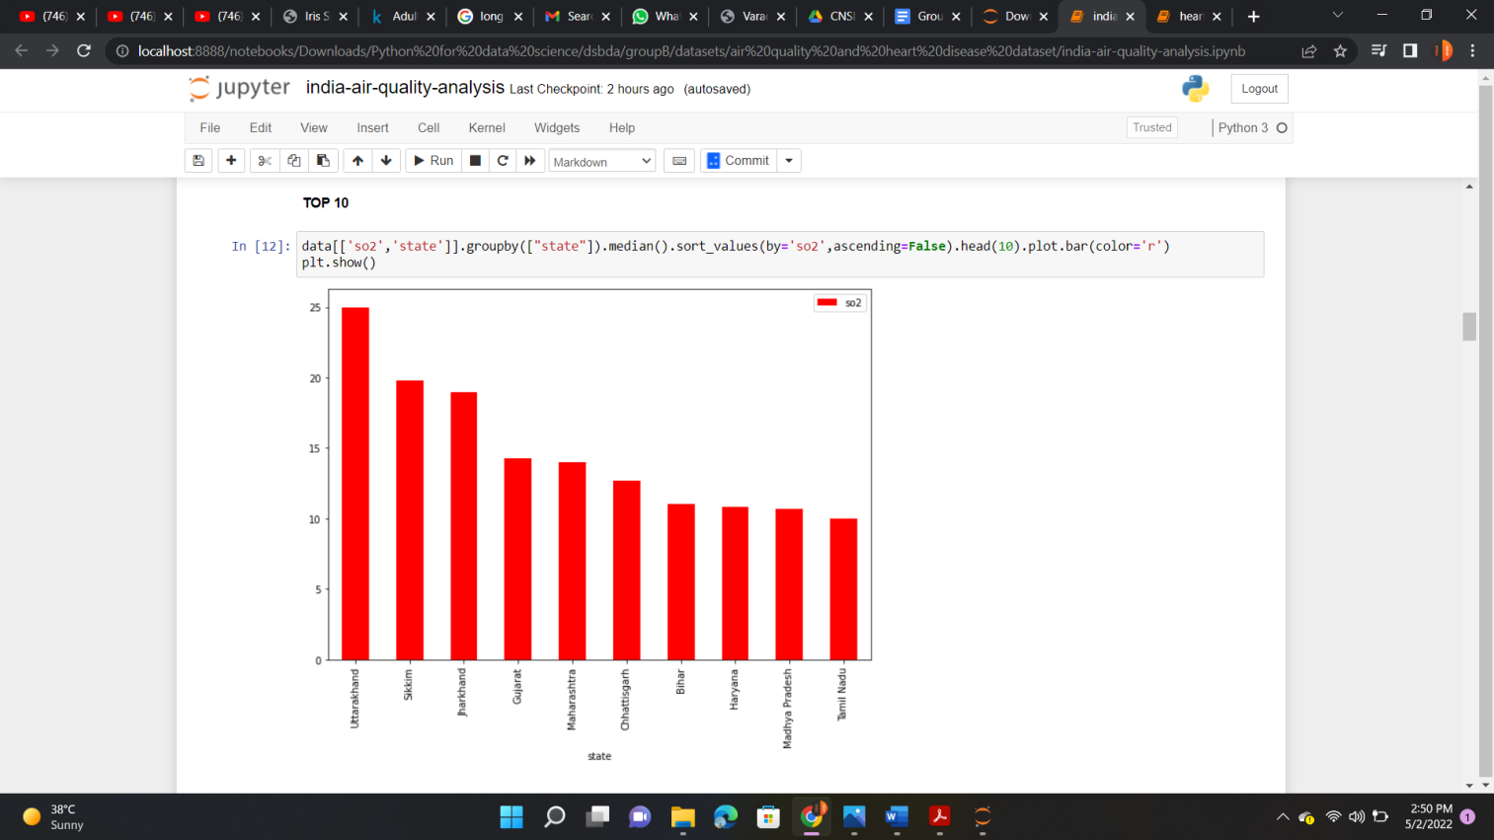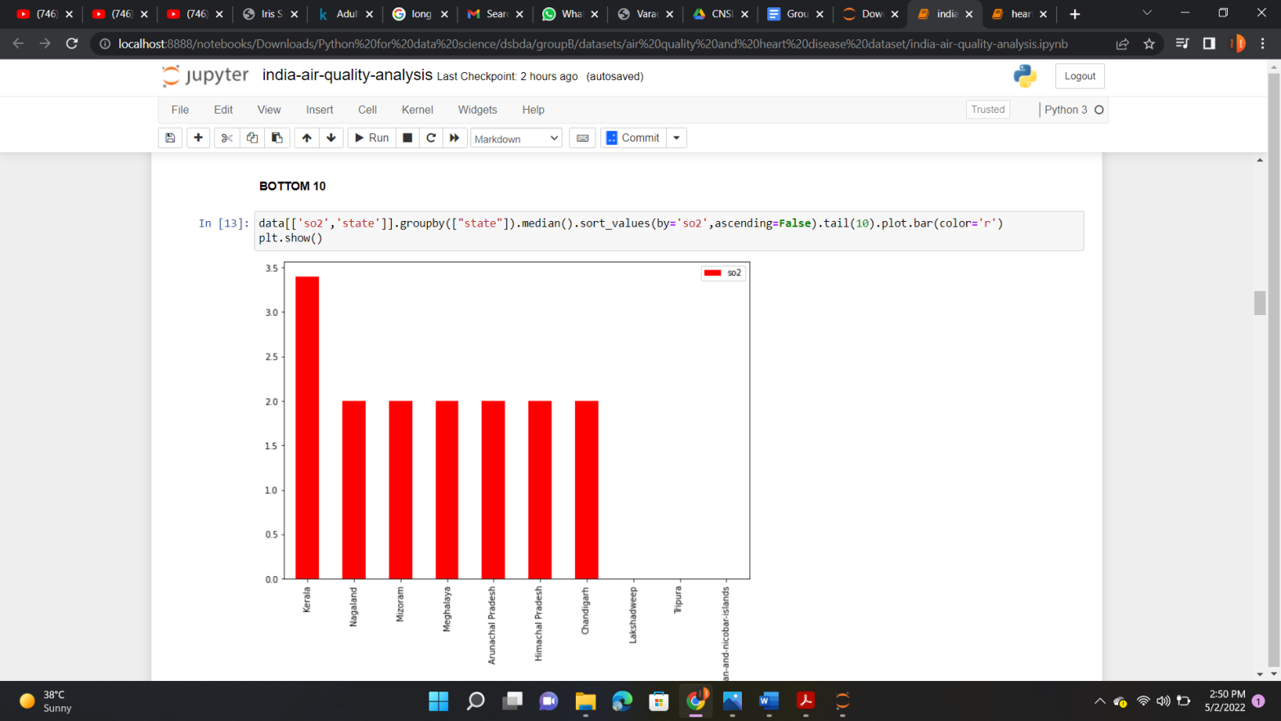



**Conclusion:** Thus given data is visualized by different ways.

## Assignment No: 9

**Title:** Perform the following data visualization operations using Tableau on Adult and Iris datasets

1) 1D (Linear) Data visualization 2) 2D (Planar) Data Visualization

3) 3D (Volumetric) Data Visualization 4) Temporal Data Visualization

5) Multidimensional Data Visualization 6) Tree/ Hierarchical Data visualization

7) Network Data visualization

### Learning Objectives:

**Problem Statement:**

Perform visualization using Tableau.

**Learning Outcome**: Students will able to

* Perform visualization on dataset.

### Software and Hardware Requirement:

* PC with Tableau installed.

### Theory:

Data visualization or data visualization is viewed by many disciplines as a modern equivalent of [visual communication.](https://en.wikipedia.org/wiki/Visual_communication) It involves the creation and study of the [visual](https://en.wikipedia.org/wiki/Visual_system) representation of [data,](https://en.wikipedia.org/wiki/Data) meaning "information that has been abstracted in some schematic form, including attributes or variables for the units of [information](https://en.wikipedia.org/wiki/Information)".

Data visualization refers to the techniques used to communicate data or information by encoding it as visual objects (e.g., points, lines or bars) contained in graphics. The goal is to communicate information clearly and efficiently to users. It is one of the steps in [data analysis](https://en.wikipedia.org/wiki/Data_analysis) or [data science](https://en.wikipedia.org/wiki/Data_science)

1D/Linear

Examples:

lists of data items, organized by a single feature (e.g., alphabetical order) (not commonly visualized)

# 2D/Planar (especially geospatial)

Examples (geospatial):

**[choropleth](http://en.wikipedia.org/wiki/Choropleth)**

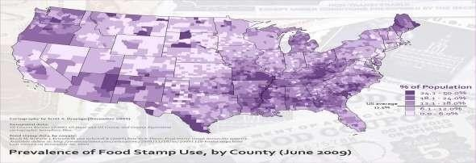

3D/Volumetric

**3D/Volumetric**

Broadly, examples of [scientific visualization:](http://en.wikipedia.org/wiki/Scientific_visualization) [3D computer models](http://en.wikipedia.org/wiki/3D_modelling)

In [3D computer graphics,](https://en.wikipedia.org/wiki/3D_computer_graphics) **3D modeling** (or **three-dimensional modeling**) is the process of developing a mathematical representation of any *[surface](https://en.wikipedia.org/wiki/Surface_(mathematics))* of an object (either inanimate or living) in [three dimensions](https://en.wikipedia.org/wiki/Three-dimensional_space) via [specialized software.](https://en.wikipedia.org/wiki/3D_computer_graphics_software) The product is called a **3D model**. Someone who works with 3D models may be referred to as a **3D artist**. It can be displayed as a two-dimensional image through a process called *[3D rendering](https://en.wikipedia.org/wiki/3D_rendering)* or used in a [computer simulation](https://en.wikipedia.org/wiki/Computer_simulation) of physical phenomena. The model can also be physically created using [3D printing](https://en.wikipedia.org/wiki/3D_printing) devices.

[surface](http://en.wikipedia.org/wiki/Scientific_visualization" \l "Surface_rendering) and [volume](http://en.wikipedia.org/wiki/Scientific_visualization" \l "Volume_rendering) rendering

[Rendering i](https://en.wikipedia.org/wiki/Rendering_(computer_graphics))s the process of generating an image from a [model,](https://en.wikipedia.org/wiki/3D_model) by means of computer programs. The model is a description of three-dimensional objects in a strictly defined language or data structure. It would contain geometry, viewpoint, [texture,](https://en.wikipedia.org/wiki/Texture_mapping) [lighting,](https://en.wikipedia.org/wiki/Texture_mapping) and shading information. The image is a [digital image](https://en.wikipedia.org/wiki/Digital_image) or [raster graphics image.](https://en.wikipedia.org/wiki/Raster_graphics) The term may be by analogy with an "artist's rendering" of a scene. 'Rendering' is also used to describe the process of calculating effects in a video editing file to produce final video output.

[Volume rendering i](https://en.wikipedia.org/wiki/Volume_rendering)s a technique used to display a 2D projection of a 3D discretely [sampled data](https://en.wikipedia.org/wiki/Sampling_(signal_processing)) [set.](https://en.wikipedia.org/wiki/Data_set) A typical 3D data set is a group of 2D slice images acquired by a [CT](https://en.wikipedia.org/wiki/Computed_axial_tomography) or [MRI](https://en.wikipedia.org/wiki/Magnetic_resonance_imaging) scanner. Usually these are acquired in a regular pattern (e.g., one slice every millimeter) and usually have a regular number of image [pixels](https://en.wikipedia.org/wiki/Pixel) in a regular pattern. This is

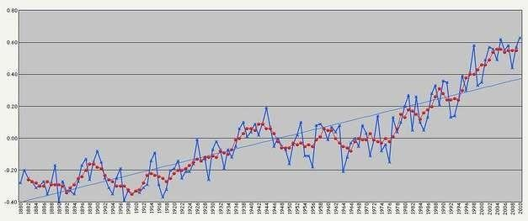



an example of a regular volumetric grid, with each volume element, or [voxel](https://en.wikipedia.org/wiki/Voxel) represented by a single value that is obtained by sampling the immediate area surrounding the voxel.

[computer simulations](http://en.wikipedia.org/wiki/Scientific_visualization" \l "Computer_simulation)

[Computer simulation](https://en.wikipedia.org/wiki/Computer_simulation) is a computer program, or network of computers, that attempts to [simulate](https://en.wikipedia.org/wiki/Simulation) an abstract [model](https://en.wikipedia.org/wiki/Model_(abstract)) of a particular system. Computer simulations have become a useful part of [mathematical modeling](https://en.wikipedia.org/wiki/Mathematical_model) of many natural systems in

physics, and computational physics, chemistry and biology; human systems in economics, psychology, and social science; and in the process of engineering and new technology, to gain insight into the operation of those systems, or to observe their behavior.[[6]](https://en.wikipedia.org/wiki/Scientific_visualization" \l "cite_note-6) The simultaneous visualization and simulation of a system is called [visulation.](https://en.wikipedia.org/wiki/Visulation)

Examples:

~~Temporal~~

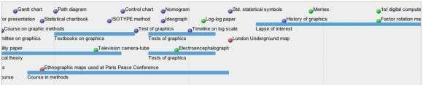

**[timeline](http://en.wikipedia.org/wiki/Timeline)**

Tools: [SIMILE Timeline, TimeFlow,](http://www.simile-widgets.org/timeline/) [Timeline JS,](http://timeline.verite.co/) [Excel](http://www.vertex42.com/ExcelArticles/create-a-timeline.html) Image:

Friendly, M. & Denis, D. J. (2001). Milestones in the history of thematic cartography, statistical graphics, and data visualization. Web

document, [http://www.datavis.ca/milestones/.](http://www.datavis.ca/milestones/) Accessed: August 30, 2012.

**[time series](http://en.wikipedia.org/wiki/Time_series)**

AISSMS IOIT, Department of Information Technology Page 67

nD/Multidimensional



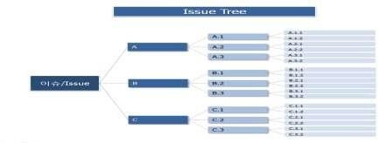

Examples (category proportions, counts):

**[histogram](http://en.wikipedia.org/wiki/Histogram)**

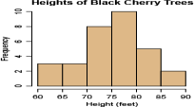

**[pie chart](http://en.wikipedia.org/wiki/Pie_chart)**

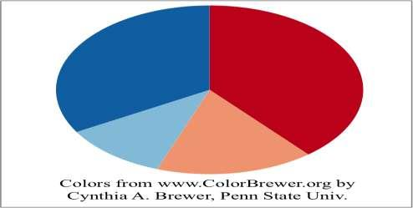

# Tree/Hierarchical

Examples:

### general tree visualization



**[dendrogram](http://en.wikipedia.org/wiki/Dendrogram)**

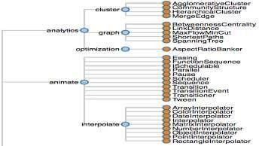

### Network

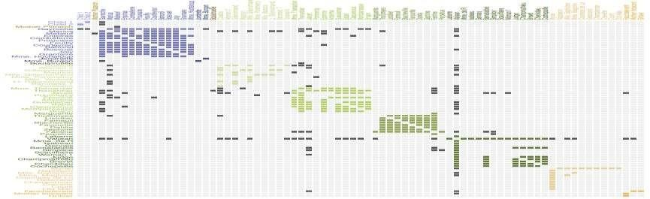

Examples:

### matrix

* + **node-link diagram (link-based layout algorithm)**



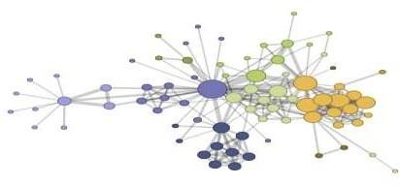

**Tableau:**

Tableau is a Business Intelligence tool for visually analyzing the data. Users can create and distribute an interactive and shareable dashboard, which depict the trends, variations, and density of the data in the form of graphs and charts. Tableau can connect to files, relational and Big Data sources to acquire and process data. The software allows data blending and real-time collaboration, which makes it very unique. It is used by businesses, academic researchers, and many government organizations for visual data analysis. It is also positioned as a leader Business Intelligence and Analytics Platform in Gartner Magic Quadrant.

**Tableau Features:**

Tableau provides solutions for all kinds of industries, departments, and data environments. Following are some unique features which enable Tableau to handle diverse scenarios.

* + - **Speed of Analysis** − As it does not require high level of programming expertise, any user with access to data can start using it to derive value from the data.
    - **Self-Reliant** − Tableau does not need a complex software setup. The desktop version which is used by most users is easily installed and contains all the features needed to start and complete data analysis.
    - **Visual Discovery** − The user explores and analyzes the data by using visual tools like colors, trend lines, charts, and graphs. There is very little script to be written as nearly everything is done by drag and drop.
    - **Blend Diverse Data Sets** − Tableau allows you to blend different relational, semi structured and raw data sources in real time, without expensive up-front integration costs. The users don’t need to know the details of how data is stored.
    - **Architecture Agnostic** − Tableau works in all kinds of devices where data flows. Hence, the user need not worry about specific hardware or software requirements to use Tableau.
    - **Real-Time Collaboration** − Tableau can filter, sort, and discuss data on the fly and embed a live dashboard in portals like SharePoint site or Salesforce. You can save your view of data and allow colleagues to subscribe to your interactive dashboards so they see the very latest data just by refreshing their web browser.
    - **Centralized Data** − Tableau server provides a centralized location to manage all of

the organization’s published data sources. You can delete, change permissions, add tags, and manage schedules in one convenient location. It’s easy to schedule extract refreshes and manage them in the data server. Administrators can centrally define a schedule for extracts on the server for both incremental and full refreshes. There are three basic steps involved in creating any Tableau data analysis report. These three steps are −

* + - **Connect to a data source** − It involves locating the data and using an appropriate type of connection to read the data.
    - **Choose dimensions and measures** − This involves selecting the required columns from the source data for analysis.
    - **Apply visualization technique** − This involves applying required visualization methods, such as a specific chart or graph type to the data being analyzed.

For convenience, let’s use the sample data set that comes with Tableau installation named sample – superstore.xls. Locate the installation folder of Tableau and go to **My Tableau Repository**. Under it, you will find the above file at **Datasources\9.2\en\_US-US**.

### Connect to a Data Source

On opening Tableau, you will get the start page showing various data sources. Under the header **“Connect”**, you have options to choose a file or server or saved data source. Under Files, choose excel. Then navigate to the file **“Sample – Superstore.xls”** as mentioned above. The excel file has three sheets named Orders, People and Returns. Choose **Orders**.

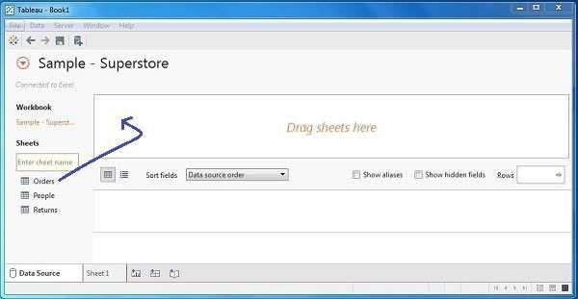

### Choose the Dimensions and Measures

Next, choose the data to be analyzed by deciding on the dimensions and measures. Dimensions are the descriptive data while measures are numeric data. When put together, they help visualize the performance ofthe dimensional data with respect to the data which are measures. Choose **Category** and **Region** as the dimensions and **Sales** as the measure. Drag

and drop them as shown in the following screenshot. The result shows the total sales in each category for each region.

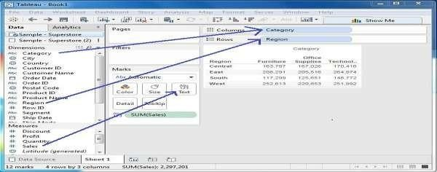

### Apply Visualization Technique

In the previous step, you can see that the data is available only as numbers. You have to read and calculate each of the values to judge the performance. However, you can see them as graphs or charts with different colors to make a quicker judgment.

We drag and drop the sum (sales) column from the Marks tab to the Columns shelf. The table showing the numeric values of sales now turns into a bar chart automatically.

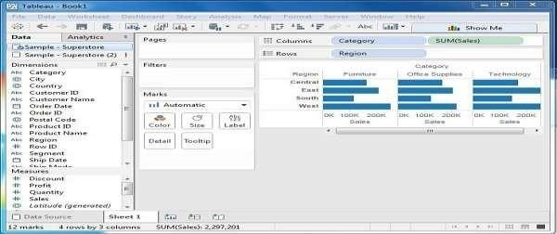

You can apply a technique of adding another dimension to the existing data. This will add more colors to the existing bar chart as shown in the following screenshot.



**DEPARTMENT OF INFORMATION TECHNOLOGY**

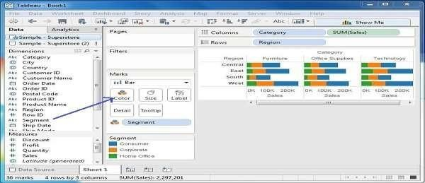

**Data visualization using Tableu:**

1. **Iris Dataset**

**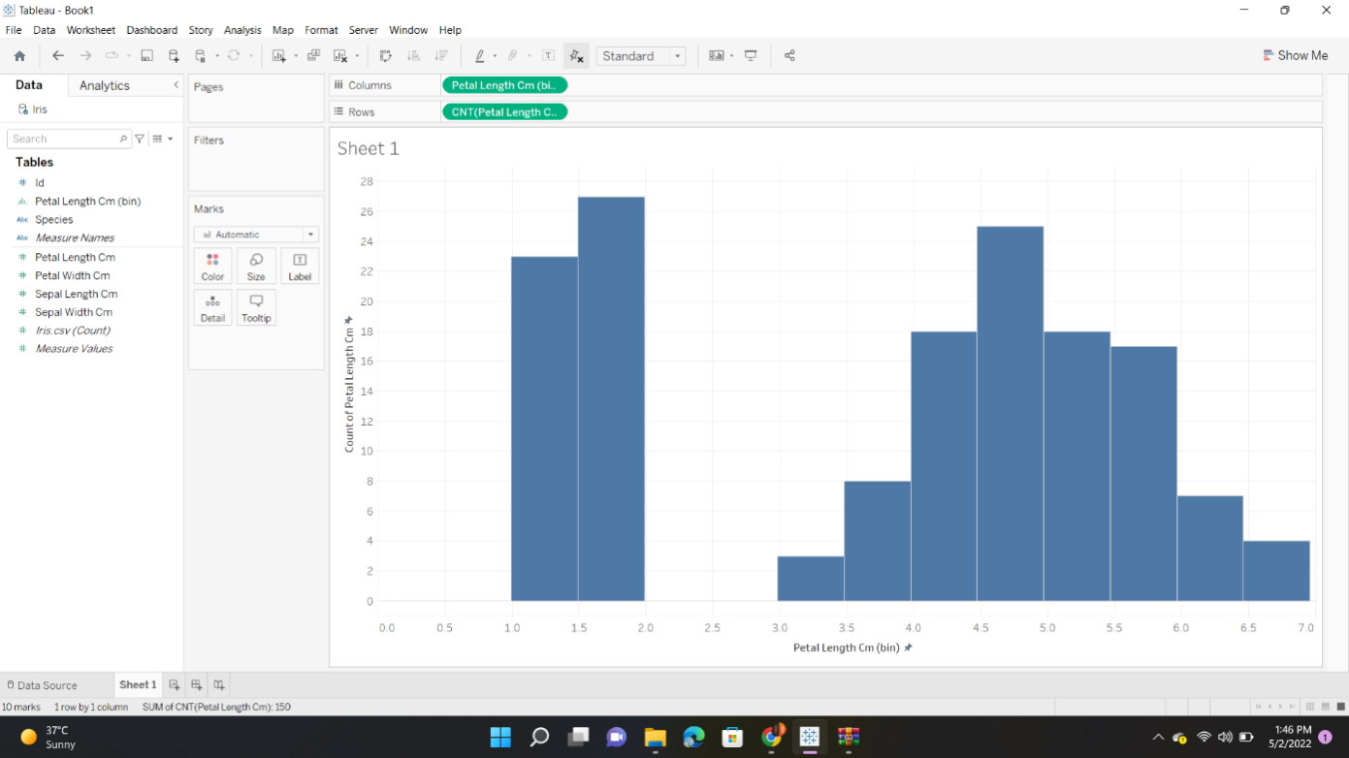**



**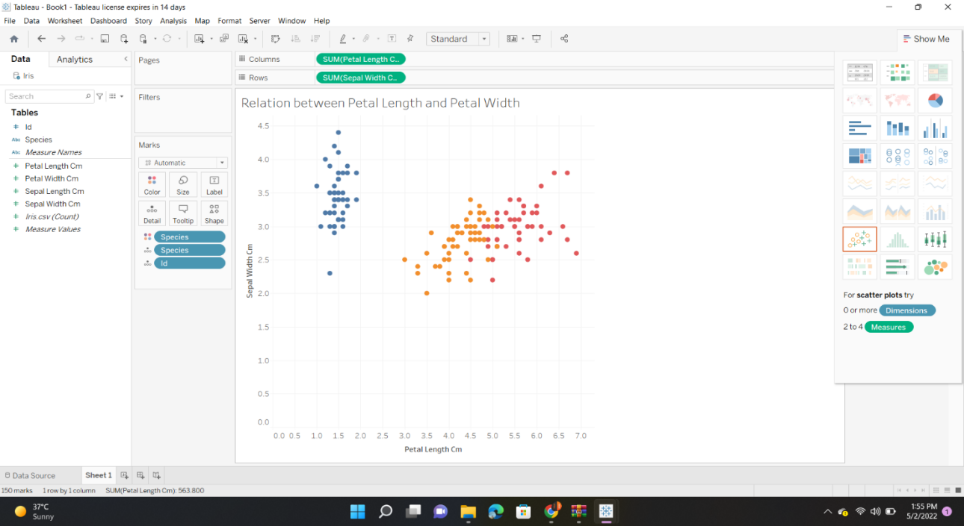**

**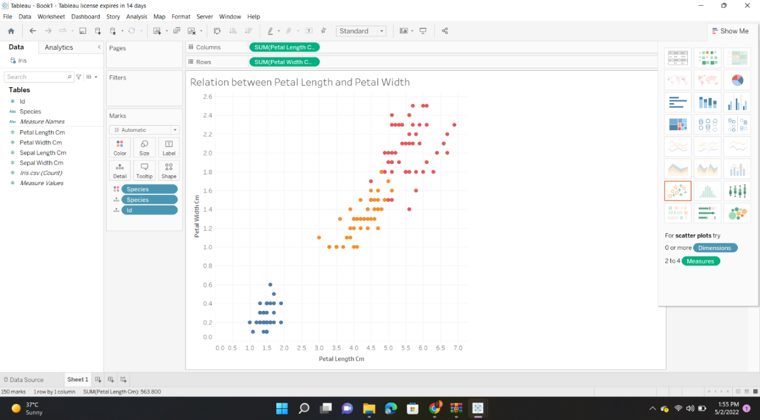**



**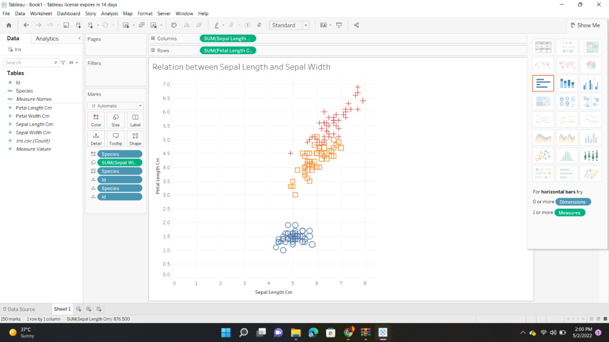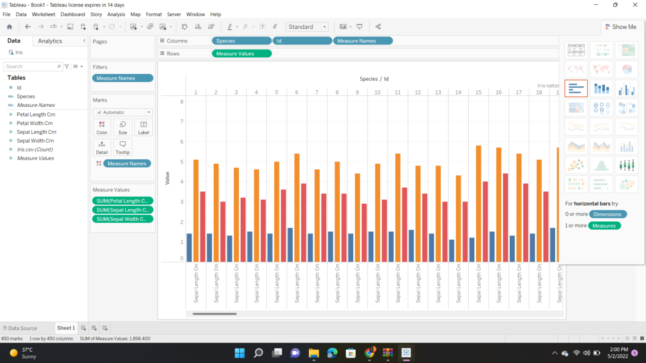**



**2.Adult dataset :**

**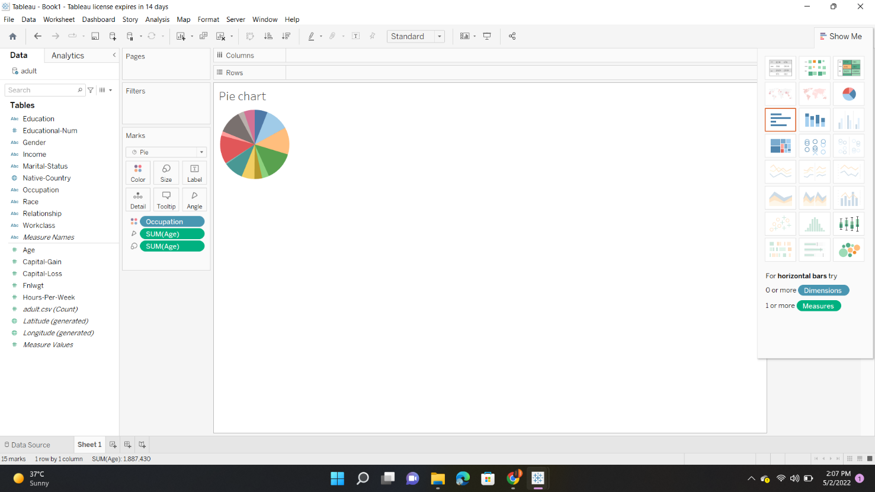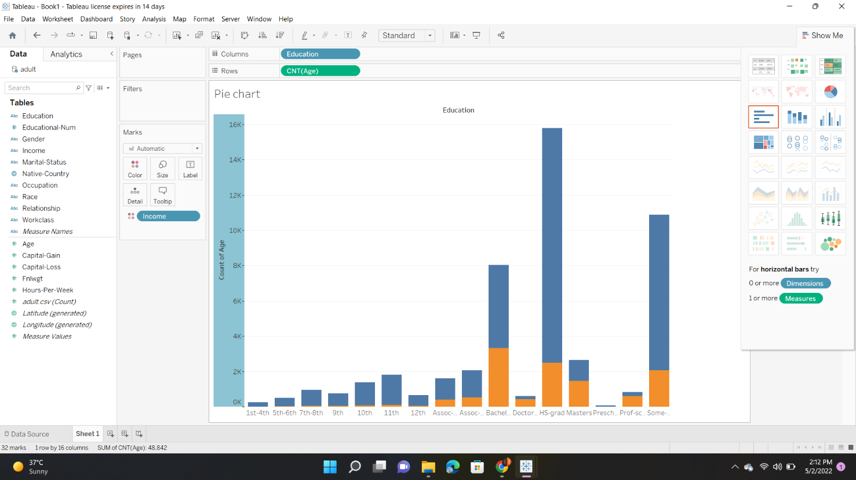**



**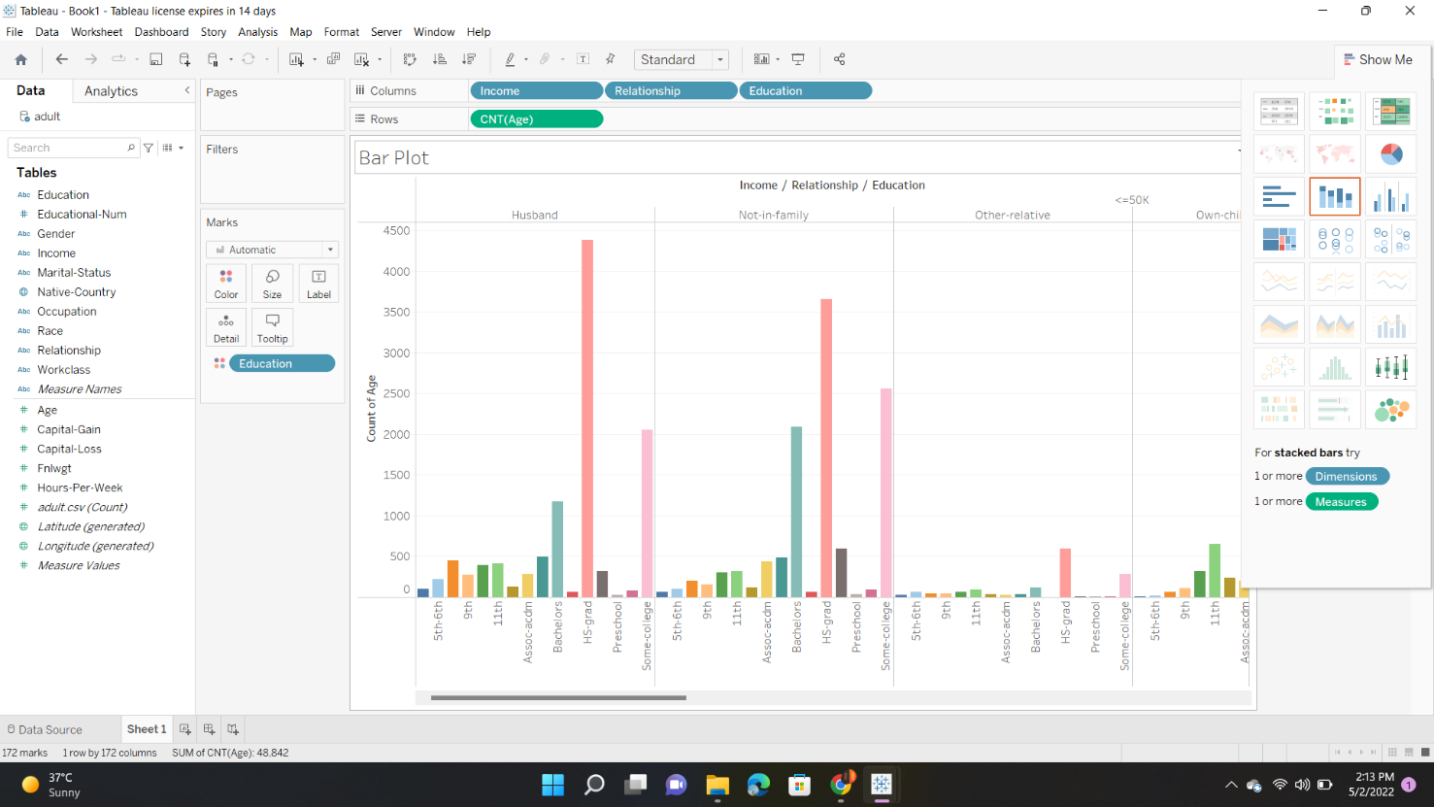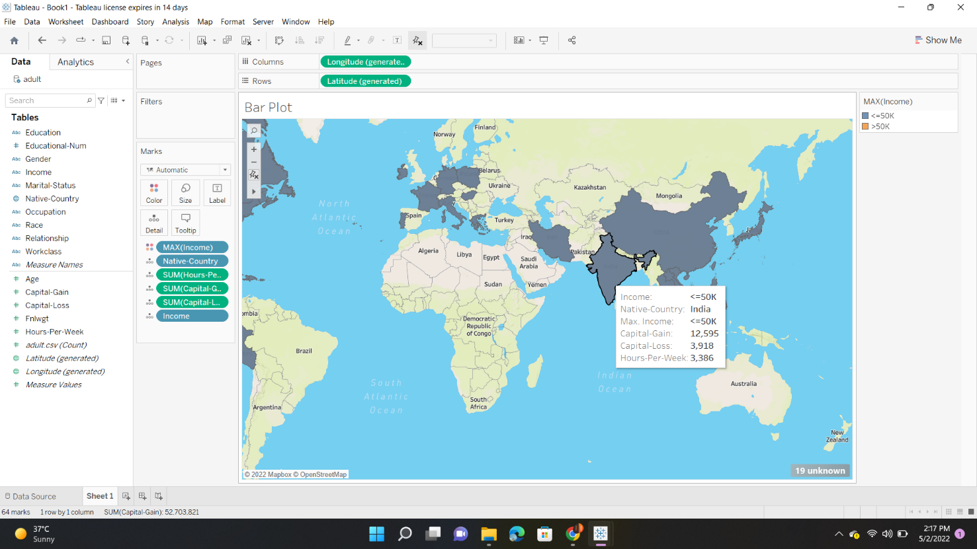**



**Conclusion:** Thus we have learnt how to Visualize the data in different types (1 1D (Linear) Data visualization,2D (Planar) Data Visualization, 3D (Volumetric) Data Visualization, Temporal Data Visualization,Multidimensional Data Visualization, Tree/ Hierarchical Data visualization, Network Data visualization) by using Tableau Software.



**DEPARTMENT OF INFORMATION TECHNOLOGY**

**References**

1. Big Data, Black Book, DT Editorial services, 2015 edition.
2. A.Ohri, “R for Business Analytics”, Springer, 2012.
3. Robert I.Kbacoff , R in Action, Dreamtech press, Second edition
4. Alex Holmes, Hadoop in practice, Dreamtech press
5. Online References for data set 1) <http://archive.ics.uci.edu/ml/>